PROJECT #3 Debate on MLK vs. Malcolm X
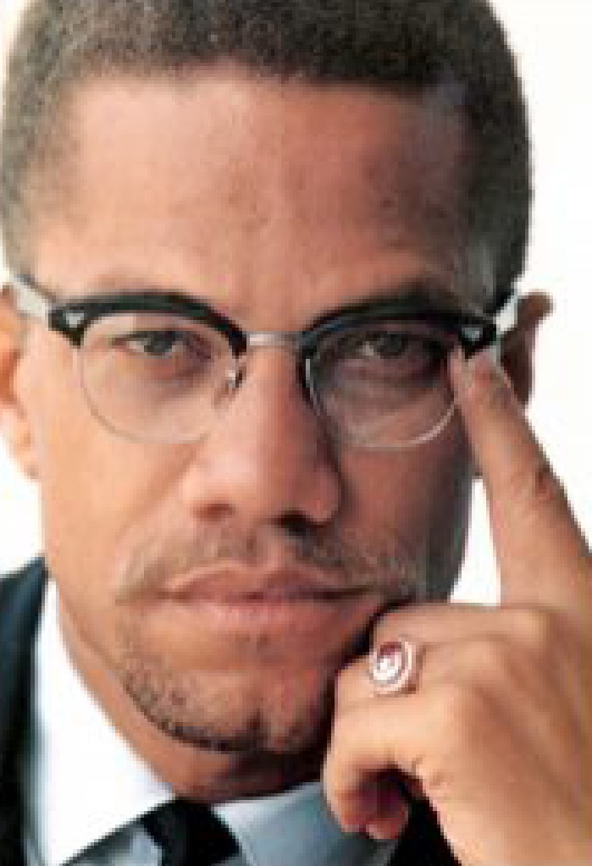 | 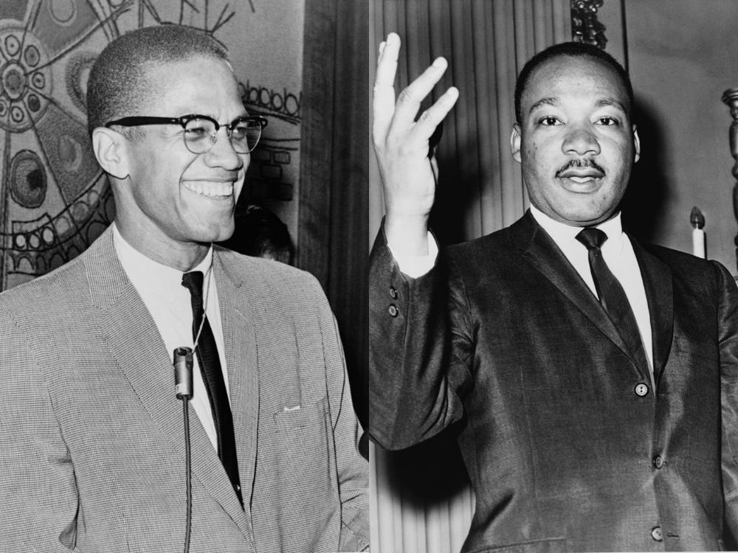
Overview: We do not have a test for Unit 7; instead, we will have only a project worth a 60- point “Project Grade”. You should be able to finish most of your preparation in class. ½ you grade will be a prepared speech/notes you upload to Canvas and ½ your grade will be your participation in the class debate. We will debate the ideas of Martin Luther King, Jr. vs the ideas of Malcolm X- and how they relate to not only US History but modern USA today as well.
The actual Debate will be on April 15 (A-Day) & April 18 (B-Day)
Your Grade:
- 30 points- your Preparation for the Debate (your research notes you upload to Canvas)
- 30 points- your Participation & Performance during the class debate

What do you need to decide and prepare?
- Will you be on the MLK Team or the Malcolm X Team?
- Once you are on a Team- will you focus on Topic 1, 2, or 3?
(We will decide this in class; however, if you are absent from class then you can choose on your own.) (If you are in class you should work with your team to help each other and make sure you are not repeating the same points and evidence!)
- Once you decide your Team and Topic- then you need to prepare basically a 3- minute speech arguing your point and giving evidence for it. You must upload to Canvas any notes for your speech and any research you collect. You can upload your entire written-out speech OR you can upload bullet-points for your speech.
- You must have organized arguments in your speech PLUS organized specific evidence to support your arguments. YOUR EVIDENCE MUST ONLY COME FROM THE USA. BUT IT CAN BE FROM EITHER USA PAST HISTORY AND/OR USA MODERN-DAY.
- HERE ARE THE 3 TOPICS YOU MUST DECIDE TO FOCUS ON ONLY ONE OF THEM FOR EITHER MLK OR MALCOLM X:

I.Topic #1 of Debate: Malcolm X vs. MLK's View on The Overall Blueprint of the Civil Rights Movement
Integration vs. Separation
-As we will soon see in our study of the US Civil Rights Movement, one divide in the movement involves the issue of integration vs. separation. Martin Luther King will argue that integration must always be at the heart of the movement; in other words, African-Americans and minorities should integrate with white America in all parts of the movement. White people should be allowed in the movement and stand alongside African-Americans in all parts of the movement. African-Americans and other minorities should have the ultimate goal also be integration into mainstream, "white" America. The goal is for African-Americans to slowly integrate into "white America" now through sit-ins and other forms of protest, with the goal that eventually minorities will be gradually integrated as equals into all parts of US society.
-Malcolm X disagrees with the blueprint and goal of integration; instead, Malcolm X calls for separation of African-Americans from mainstream "white" America. First of all, protests and other struggles in the movement should be done exclusively by African-Americans and minorities themselves. If "whites" take part in the movement it will diminish the power and revolutionary nature of the movement itself. In addition, if African-Americans truly want "equality" in the USA they must first separate themselves from "white America" and build up the strength of their communities themselves. Only then will white America respect African-Americans and consider them equal. If African-Americans try to integrate into white America first they will never garner the strength to achieve true equality. So the overall blueprint for the Civil Rights Movement should not be integration and then granted equality; instead, it should be separation then forced equality.
-So this is Topic #1 of the Debate. Do you agree with Malcolm X or MLK’s view?

II.Topic #2 of Debate: The Methods of The Civil Rights Movement
Nonviolence vs. "By Any Means Necessary"
-As we will also soon see in our study of Unit 7, another split in the movement revolves around the methods and means to be used in the Civil Rights Movement. You probably already know that Martin Luther King will insist that Total Nonviolence must be at the heart of everything in the movement. Even in the face of extreme brutality and violence, all participants in the Civil Rights Movement must be completely and forever committed to never using any form of violence. Therefore, we will see the use of nonviolent methods such as peaceful sit-ins, marches, and speeches, etc.
-Although it must be mentioned that Malcolm X will never himself participate in any acts of violence as part of the Civil Rights Movement, Malcolm X disagrees that the movement must always and forever only use nonviolent methods. His famous phrase is that he will achieve equality "by any means necessary": if nonviolence works then great, but if it doesn't work then African-Americans have the right to consider other options also. Malcolm X argues this is only acting as a true American acts- Americans who have used guns and violence to fight for equality all through USA History. If George Washington can use violence for equality and be a hero, why can't the African-American do the same, especially in the face of extreme violence and brutality? Finally, Malcolm X will criticize a lot of the nonviolent methods we will study in this Unit as ineffective and beneath the dignity of African-Americans (what's the point of allowing a police dog to bite a peaceful girl protesting or allow a policeman to spray water hoses at her?)
-So this is Topic #2 of the Debate. Do you agree with Malcolm X or MLK’s View of Topic #2?

III.Topic #3 of Debate: The overall GOAL of the movement
The American Dream vs The American Nightmare
-Topic #3 steps back and asks the big picture question: are African-Americans (and other minorities) truly better off living in the USA or not? For Martin Luther King the answer is yes. The USA (and Christianity) already have the perfect ideas: equality, democracy, and brotherly love. Now African-Americans and other minorities just need to work together to make these ideals a reality. This is the essence of Martin Luther King's famous "I Have a Dream" speech. So the ultimate goal of the Civil Rights Movement is for African-Americans to stay and become part of a true United States of America.
Malcolm X on the other hand is not afraid to ask the question of maybe "The American Dream" is actually only an "American Nightmare" for African-Americans and other minorities. More important than ideals is maybe reality; and for Malcolm X the reality is that living in the USA has always been- and will always be- a nightmare for African-Americans and minorities. From slavery to segregation to police brutality the USA is a dangerous and nightmarish place for African-Americans. Similarly, Malcolm X believes that Christianity is "the white man's religion" and is a religion designed to keep whites in control over minorities. This is the religion of the slavemaster and it is meant to control its slaves. Therefore, Malcolm X believes that African-Americans must turn towards a different religion for salvation, and it should be a religion started by people of color. For Malcolm X, the only religion to assist African-Americans is Islam. So, unlike Martin Luther King who sees the end goal in the USA, Malcolm X wants African-Americans to join the larger international struggle of people of color where perhaps the USA is the enemy?
-So this is Topic #3 of the Debate. Do you agree with Malcolm X or MLK’s View of Topic #3?
SO WHAT DO I NEED TO DO NOW?
- Decide now do you want to be on the Malcolm X Team or the Martin Luther King Team for this Debate? (We will now separate in the classroom into 2 Teams)
- Once you are in your Team- now decide which of the 3 Topics do you want to focus on? (We will split our teams into smaller groups now to work on either Topic 1, 2, or 3)
- Brainstorm with your small topic team now what points, arguments, and evidence you will make. You do not want to repeat the exact same evidence as your partners. You can help each other with ideas, but in the end you need to write your own 3 minute speech and find your own evidence. (In class you should brainstorm with your partners now)
- NOW INDIVIDUALLY you need to collect evidence for your 3 minute speech. (Like all History exams, papers, and debates, you need specific evidence to get an “A”). Remember your evidence must come from the USA- but it can (and should) come from BOTH USA History AND ALSO MODERN USA. I think an A+ speech will have evidence from something in Unit 7 (Civil Rights Movement); plus something from either another time period in US History or modern USA. (In class you should do 20-30 minutes of research now. After 20-30 minutes of individual research then share your ideas with your partners)
- Finally- you yourself need to write your own 3-minute speech you will give during the debate.
- Don’t forget ½ your grade is you yourself must upload to Canvas your speech (either written out or bullet points) and any research notes you want to show me.
- Be prepared to give your speech to the class on debate day.
- Be prepared to engage in debate in argument with the other team on debate day.
