PAPER 1 BIOLOGICAL APPROACH REVIEW SHEET
Paper One has two sections – A and B. In Section A you have three compulsory short answer questions, one from each approach (biological, cognitive and sociocultural). In Section B, you have three exam questions, also one from each approach and you answer only one. This means you should prep all core approach topics for SAQs and you can choose one (or two?) approaches for essays.
Biological Approach
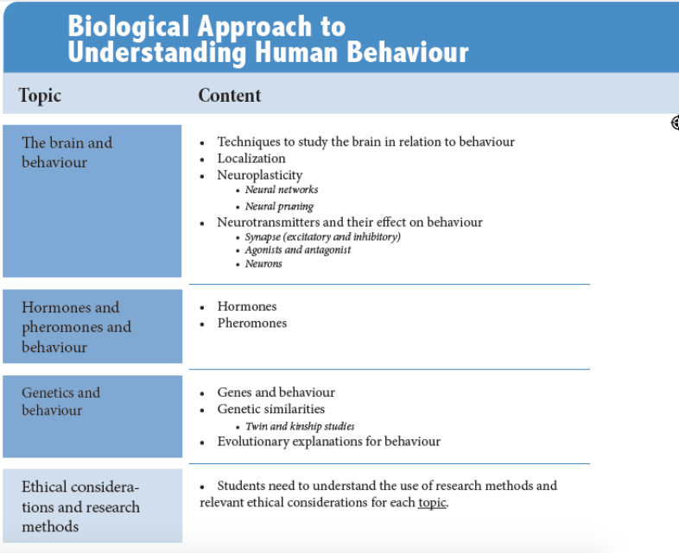
Terms in italics will be in SAQs only (not essays) and will only be in exams from May 2020 – not in May or Nov 2019 exams. This table is taken from our Revision Guide (available here).

Exam Questions
TOPIC | Content | SAQs | Essay Questions
The brain and behaviour | Techniques to study the brain in relation to behaviour | - Describe the use of one technique used to study the brain in relation to behaviour. | - Evaluate the use of one technique used to study the brain in relation to behaviour.  - Discuss the use of one or more techniques used to study the brain in relation to behaviour.
 | Neuroplasticity | - Explain one example of neuroplasticity.  - Explain how one study demonstrates neuroplasticity. | - Discuss one example of neuroplasticity.  - Evaluate one or more studies related to neuroplasticity.  - Discuss neuroplasticity with reference to one or more studies.
 | Neural networks*  *terms in italics will not be in 2019 exams | - Explain how neural networks are formed. | SAQ term only.
 | Neural pruning | - With reference to one study, explain neural pruning. | SAQ term only.
 | Neurotransmitters and their effect on behaviour | - Explain the effect of one neurotransmitter on behaviour.  - Describe how one example illustrates the effect of neurotransmitters on human behaviour. | - Discuss one or more effects of one neurotransmitter on human behaviour.  - Discuss the effects of one or more neurotransmitters on human behaviour.  - To what extent does one neurotransmitter affect human behaviour.
 | Synapse (excitatory/inhibitory) | - Outline one example of an excitatory or inhibitory neurotransmitter.· | SAQ term only.
 | Agonists and antagonist | - Outline one example of how an agonist and/or antagonist may affect a neurotransmitters influence on behaviour. (Or, SAQs could ask for one agonist or one agonists influence on behaviour) | SAQ term only.
 | Neurons | - Explain how excitatory and/or inhibitory neurons affect human behaviour. | SAQ term only.
 | Localization | - Explain one example of localization of function in the brain.  - Outline how one study demonstrates localization of function in the brain.  - Using one or more examples, explain localization of function. | - Evaluate research related to localization of function.  - Discuss localization of function in the brain.
Hormones and pheromones and behaviour | Hormones | - Explain how one hormone affects human behaviour.  - Outline one effect of one hormone on human behaviour. | - Discuss one or more effects of one hormone on human behaviour.  - Discuss the effects of one or more hormones on human behaviour.  - To what extent does one hormone affect human behaviour.
 | Pheromones | - Outline one study related to pheromones and behaviour.  - Explain one example of how human behaviour may be influenced by pheromones. | - Discuss research related to pheromones and behaviour.
Genetics and behaviour | Genes and behaviour | - Outline one study related to the study of genes and behaviour.  - Explain how genes may affect one behaviour. | - Evaluate one study or theory related to the influence of genes on behaviour.  - Discuss how genes may affect human behaviour.  - To what extent do genes influence human behaviour?
 | Genetic similarities | - Explain how genetic similarities are used in studies on genes and behaviour. | - Discuss how genetic similarities are used in studies on genes and behaviour.
 | Twin and kinship studies | - Describe one example of a twin or kinship study.  - Explain how twin and/or kinship studies are used to understand the effects of genes on behaviour. | SAQ term only.
 | Evolutionary explanations for behaviour | - Describe one evolutionary explanation of behaviour. | - Discuss one or more evolutionary explanations for one behaviour.  - To what extent can evolution explain one behaviour.
Research Methods & Ethical Considerations
Questions about research methods and ethics will be based on the three “topics” for the biological approach (the brain and behaviour, hormones and pheromones and behaviour and genetics and behaviour).
Research Methods
Short Answer Questions
- Outline one research method used to study the brain and behaviour.
- Describe the use of one research method used to study hormones and/or pheromones and behaviour.
- Explain how and why one research method is used to study genetics and behaviour.
- Explain the use of one research method used in the biological approach to understanding human behaviour.
Essay Questions
- Discuss one research methods used to study the brain and behaviour.
- Evaluate one or more research methods used to study the brain and behaviour.
- Evaluate the use of one research method used to study hormones and/or pheromones and behaviour.
- Evaluate how and why one research method is used to study genetics and behaviour.
- Discuss the use of one or more research methods used in the biological approach to understanding human behaviour.
Ethical Considerations
Short Answer Questions
- Outline one ethical consideration related to studies on the brain and behaviour.
- Explain one ethical consideration relevant to studies on hormones and/or pheromones and behaviour.
- Explain one ethical consideration relevant to one study on genetics and behaviour.
- Outline one ethical consideration related to studies in the biological approach to understanding human behaviour.
Essay Questions
- Discuss one ethical consideration relevant to studies on the brain and behaviour.
- Discuss one ethical consideration relevant to one study on hormones and/or pheromones and behaviour.
- Discuss ethical considerations relevant to research on hormones and pheromones and behaviour.
- Discuss one or more ethical considerations relevant to research on genetics and behaviour.
- Discuss one or more ethical considerations related to research in the biological approach to understanding human behaviour.

Disclaimer: These questions are not IB “official” questions and are written with our best guess as to what the probable exam questions may look like. Therefore, not every possible question is covered.
Notes
- For short answer questions, because you can use the command terms interchangeably (outline, describe, explain) their selection for the above questions has been random.
- The italicized terms above (e.g. neural pruning) are the SAQ additional terms. It’s very difficult to predict how these will be phrased in IB exam questions.

