Con-Indian Removal Act Primary Documents
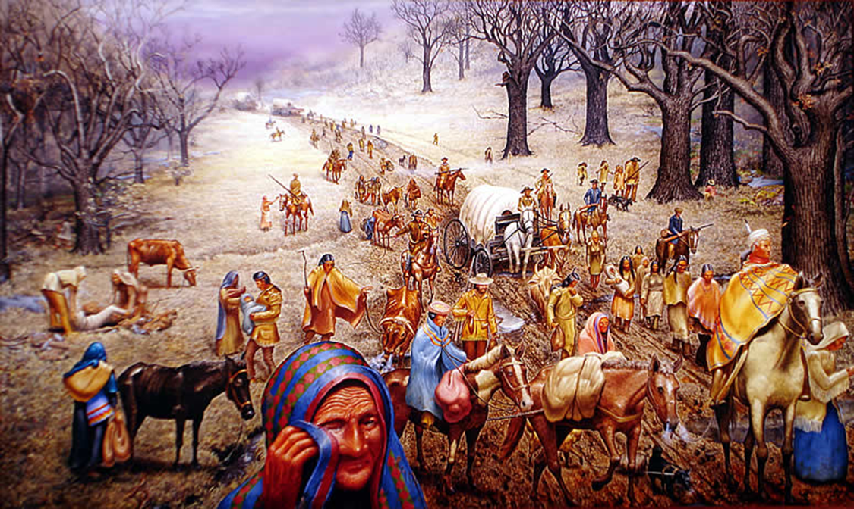

The Teardrop is the Essence of the Trail of Tears
by Max Standley
Trail of Tears Document A
“Our Hearts are Sickened”: Letter from Chief John Ross of the Cherokee, Georgia, 1836
By the stipulations of this instrument, we are despoiled of our private possessions, the indefeasible property of individuals. We are stripped of every attribute of freedom and eligibility for legal self-defence. Our property may be plundered before our eyes; violence may be committed on our persons; even our lives may be taken away, and there is none to regard our complaints. We are denationalized; we are disfranchised. We are deprived of membership in the human family! We have neither land nor home, nor resting place that can be called our own. And this is effected by the provisions of a compact which assumes the venerated, the sacred appellation of treaty.
We are overwhelmed! Our hearts are sickened, our utterance is paralized, when we reflect on the condition in which we are placed, by the audacious practices of unprincipled men, who have managed their stratagems with so much dexterity as to impose on the Government of the United States, in the face of our earnest, solemn, and reiterated protestations.
In truth, our cause is your own; it is the cause of liberty and of justice; it is based upon your own principles, which we have learned from yourselves; for we have gloried to count your [George] Washington and your [Thomas] Jefferson our great teachers; we have read their communications to us with veneration; we have practised their precepts with success. And the result is manifest. The wildness of the forest has given place to comfortable dwellings and cultivated fields, stocked with the various domestic animals. Mental culture, industrious habits, and domestic enjoyments, have succeeded the rudeness of the savage state.
We have learned your religion also. We have read your Sacred books. Hundreds of our people have embraced their doctrines, practised the virtues they teach, cherished the hopes they awaken, and rejoiced in the consolations which they afford. To the spirit of your institutions, and your religion, which has been imbibed by our community, is mainly to be ascribed that patient endurance which has characterized the conduct of our people, under the laceration of their keenest woes. For assuredly, we are not ignorant of our condition; we are not insensible to our sufferings. We feel them! we groan under their pressure! And anticipation crowds our breasts with sorrows yet to come. We are, indeed, an afflicted people! Our spirits are subdued! Despair has well nigh seized upon our energies! But we speak to the representatives of a Christian country; the friends of justice; the patrons of the oppressed. And our hopes revive, and our prospects brighten, as we indulge the thought. On your sentence, our fate is suspended; prosperity or desolation depends on your word. To you, therefore, we look! Before your august assembly we present ourselves, in the attitude of deprecation, and of entreaty. On your kindness, on your humanity, on your compassion, on your benevolence, we rest our hopes. To you we address our reiterated prayers. Spare our people! Spare the wreck of our prosperity! Let not our deserted homes become the monuments of our desolation! But we forbear! We suppress the agonies which wring our hearts, when we look at our wives, our children, and our venerable sires! We restrain the forebodings of anguish and distress, of misery and devastation and death, which must be the attendants on the execution of this ruinous compact.

Source: John Ross, The Papers of Chief John Ross, vol 1, 1807–1839, Norman OK Gary E. Moulton, ed. University of Oklahoma Press, 1985, p. 458–461.

Trail of Tears Document B
2 Primary Documents
Account of John G. Burnett, Cherokee Messenger
http://www.powersource.com/cherokee/burnett.html
…I saw the helpless Cherokees arrested and dragged from their homes, and driven at the
bayonet point into the stockades. And in the chill of a drizzling rain on an October morning
I saw them loaded like cattle or sheep into six hundred and forty-five wagons and started
toward the west…
…One can never forget the sadness and solemnity of that morning. Chief John Ross led in
prayer and when the bugle sounded and the wagons started rolling many of the children
rose to their feet and waved their little hands good-by to their mountain homes, knowing
they were leaving them forever. Many of these helpless people did not have blankets and
many of them had been driven from home barefooted…
…On the morning of November the 17th we encountered a terrific sleet and snow storm
with freezing temperatures and from that day until we reached the end of the fateful
journey on March the 26th, 1839, the sufferings of the Cherokees were awful. The trail of
the exiles was a trail of death. They had to sleep in the wagons and on the ground without
fire. And I have known as many as twenty-two of them to die in one night of pneumonia due
to ill treatment, cold, and exposure. Among this number was the beautiful Christian wife of
Chief John Ross. This noble hearted woman died a martyr to childhood, giving her only
blanket for the protection of a sick child. She rode thinly clad through a blinding sleet and
snow storm, developed pneumonia and died in the still hours of a bleak winter night, with
her head resting on Lieutenant Greggs saddle blanket…
Account of a Traveler who signed himself, “A Native of Maine”
The New York Observer- January 1839
http://marchand.ucdavis.edu/lessons/HS/CherokeeHS.htm
On Tuesday evening we fell into a detachment of the poor Cherokee Indians, about eleven
hundred…We found them in the forrest camped for the night…under a severe fall of
rain…many of the aged Indians were suffering extremely from the fatigue of the journey,
and ill health…We found the road literally filled with a procession for nearly three miles in
length…The sick and feeble were carried in wagons…multitudes go on foot--even aged
females apparently nearly ready to drop in the grave, were traveling with heavy
burdens…on the sometimes frozen ground…with no covering for feet…They buried 14 or
15 at every stopping place…some carry a downcast dejected look…of despair, others wild
frantic appearance as if to pounce like a tiger upon their enemies…
-Native American RemovalDirections--

