Introduction to Bob Marley and Rastafarianism
Bob Marley
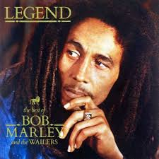
Jamaica
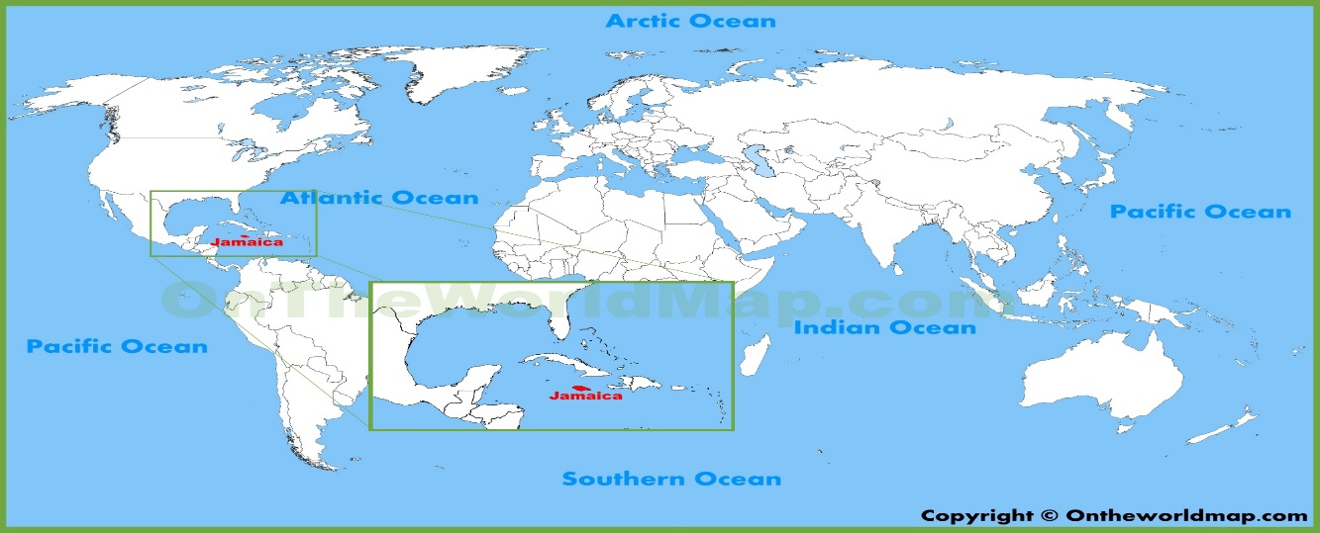
- Watch this brief mini biography video of Bob Marley:
https://www.biography.com/video/bob-marley-mini-biography-43525699852

- Read this introduction to Bob Marley, reggae, and the Rastafarian religion:
https://camirricketts.wordpress.com/essays/essay-1/

- Read this essay about how Bob Marley used his own 'intuition' and 'inspiration' to interpret the Bible Old Testament in a new way:

https://tcpc.blogs.com/musings/2005/01/the_bible_and_b.html

