Diplomacy & Cinderella Man Discussion
Discuss these questions with your Team for part of your Class Participation Grade.
- Diplomacy
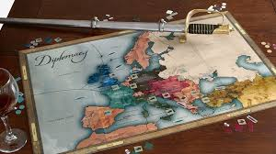
- What are your overall thoughts and opinions about playing the game Diplomacy?

- How does playing the game Diplomacy relate to causes of World War I and World War II? Explain.

- How does playing the game Diplomacy relate at all to what actually happened in World War I and World War II?

- How did you see the importance of geography in both Diplomacy and World History?
In specific, does a country's specific geography impact its decisions and histories? Explain.
For example, how does the geography of…Germany, England, Russia, and the USA affect (or even determine) its history?

- How does Diplomacy relate to what President Wilson was trying to do in his 14 points?

- What does Diplomacy teach you about "the state of the world and international politics?"

- If this game is the state of the modern world, is it possible for a country to NOT play this game? What would happen to a country that wanted to just stay out of this game?

- What is the difference between "those who are playing the game Diplomacy" by making decisions as leaders of countries and "those who are doing the actual fighting on the ground" such as we saw in "All Quiet on the Western Front."?

- Read the lyrics to one of Bob Dylan's first-ever songs called 'Masters of War". He wrote this song when he was not too much older than you. After you read the lyrics discuss with your team what are the main ideas of this song and how do they relate to Question #6 about Diplomacy?

Lyrics on next page…..

BOB DYLAN- MASTERS OF WAR
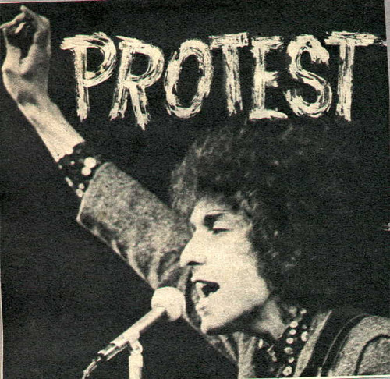
Come, you masters of war
You that build the big guns
You that build the death planes
You that build all the bombs
You that hide behind walls
You that hide behind desks
I just want you to know
I can see through your masks

[Verse 2]
You that never done nothing
But build to destroy
You play with my world
Like it’s your little toy
You put a gun in my hand
And you hide from my eyes
And you turn and run farther
When the fast bullets fly

[Verse 3]
Like Judas of old
You lie and deceive
A world war can be won
You want me to believe
But I see through your eyes
And I see through your brain
Like I see through the water
That runs down my drain

[Verse 4]
You fasten all the triggers
For the others to fire
Then you set back and watch
While the death count gets higher
You hide in your mansion
While the young people’s blood
Flows out of their bodies
And is buried in the mud

[Verse 5]
You’ve thrown the worst fear
That can ever be hurled
Fear to bring children
Into the world
For threatening my baby
Unborn and unnamed
You ain't worth the blood
That runs in your veins

[Verse 6]
How much do I know
To talk out of turn
You might say that I’m young
You might say I’m unlearned
But there’s one thing I know
Though I’m younger than you
Even Jesus would never
Forgive what you do

[Verse 7]
Let me ask you one question
Is your money that good
Will it buy you forgiveness
Do you think that it could
I think you will find
When your death takes its toll
All the money you made
Will never buy back your soul

[Verse 8]
And I hope that you die
And your death will come soon
I will follow your casket
By the pale afternoon
And I’ll watch while you’re lowered
Down to your deathbed
And I’ll stand over your grave
'Til I’m sure that you’re dead

- Cinderella Man Discussion
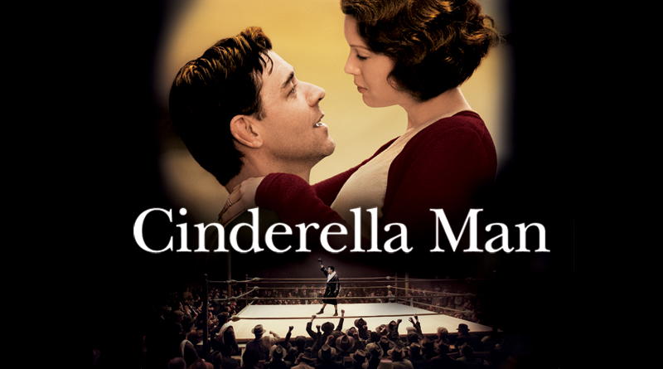
- What are your overall thoughts, reactions, and opinions to watching the movie Cinderella Man?

- How does the movie specifically show and also SYMBOLICALLY REPRESENT the following….
- The Great Depression
- The New Deal
- World War II

- What are the overall THEMES and SYMBOLIC MEANINGS in this movie?
- Discuss the symbolism and meanings of these specific scenes from the movie:
- When the family is tearing down an advertisement sign that says "Buy Your New Car at Esso" in order to get firewood to stay warm.
- Braddock is watching the video of Max Baer killing the other boxer and when Braddock stares into Baer's face Baer's face is just all black and without any emotion at all.
- On the day of the fight when Braddock says good-bye to his wife and children.
- When Braddock's wife- Mae- is listening to the fight on the radio and can barely breathe.
- When in the last round of the match between Braddock and Baer all the "poor, common" people dressed in "common clothes" run down from the top seats of Madison Square Garden and flood the "rich people" expensive seats next to the boxing ring.

- Remember I said a great research topic is "How does art both reflect and influence US History and culture?". Well another great topic is this: "How do SPORTS (especially sports in the USA) both reflect and influence US History and culture?"
-Discuss this question.
-How do you see it in the movie?
-Give more examples of both sports and/or sports figures that both reflect and influence USA History and culture?

- How does this movie relate to the overall eternal question of the Ancient Greeks: "One's character defines one's personal destiny. Also, a country's character also determines a country's destiny."

- Finally on my website read "Week 3 FDR Speech on Freedom" only the parts I mark you to read. With your team discuss the main ideas in this speech and how it relates to the movie "Cinderella Man"?

