A Different Interpretation of the Korean War

Source: http://peacehistory-usfp.org/korean-war/

Part One: US imperial ambitions in Asia
Beyond occupying South Korea at the end of World War II, U.S. involvement in Korea was a consequence of the long American drive for power in the Asia-Pacific region dating to the seizure of Hawaii and conquest of the Philippines at the turn of the 20thcentury. This mission was motivated by a trinity of military, missionary, and business interests. After the defeat of Japan in World War II, the prospect opened up that the region could come under U.S. influence, its rich resources tapped for the benefit of American industry. In a March 1955 Foreign Affairs article, William Henderson of the Council on American Foreign Relations (which Laurence Shoup and William Minter aptly termed the “imperial brain trust”) wrote: “As one of the earth’s great storehouses of natural resources, Southeast Asia is a prize worth fighting for. Five sixths of the world’s rubber, and one half of its tin are produced here. It accounts for two thirds of the world output in coconut, one third of the palm oil, and significant proportions of tungsten and chromium. No less important than the natural wealth was Southeast Asia’s key strategic position astride the main lines of communication between Europe and the Far East.”[20] To secure access to these resources and potential markets, the U.S. established a chain of military bases from the Philippines through the Ryukyu Archipelago in southern Japan.
The victory of the communists in the Chinese revolution cut off American access to the vast China market and shattered longstanding American dreams of bringing China into the American sphere of influence. The revolution also represented an ideological challenge in advancing the Russian model of state-driven socialist industrial development as an alternative to Western capitalism. Since the 1930s, the United States had been committed to Chinese nationalist leader Jieng Jieshi as a bulwark of an American dominated Asia. The U.S. continued to support Jieng after he violently consolidated his power as leader of Taiwan and co-founded the People’s Anti-Communist League with Syngman Rhee.[21]
For the American right, the “loss of China” was a devastating blow, prompting the embrace of an Asian-centric rollback policy.[22] Supporters of this policy, including mid-western Republican Senators Robert Taft of Ohio and Kenneth Wherry of Nebraska, considered Asia as a place where the U.S. could extract minerals and gain profit while spreading American and Christian ideals. Their vision dovetailed with that of free-enterprise liberals who believed in the American mission to promote free-trade and development in the backwards regions of the globe. They feared China’s obtaining a great-power status capable of allowing it to challenge an Asian system shaped by America.[23]
Japan was the super-domino in the postwar containment strategy. American leaders were committed to rebuilding Japan along capitalist lines in part by opening up regional markets. This policy gained greater urgency as a result of the Chinese revolution of 1949, whose primary goal was to escape the yoke of Japanese and Western neocolonialism by spearheading industrialization and implementing land reform and collectivized agriculture along with programs of uplift for poor peasants.[24] State Department internationalists pushed for connecting South Korea’s economy to Japan’s, in part to enable Japan to extract raw materials capable of sustaining its economic recovery, and in part to keep Japan in the Western orbit as a counterweight to communist China. In January 1947, Secretary of State George Marshall scribbled a note to Dean Acheson: “Please have plan drafted of policy to organize a definite government of So. Korea and connect up its economy with that of Japan.”[25] The war ultimately served as a great boon to Japan’s economy and the U.S. acquired military bases in South Korea that are still in its possession today.
The communist victory in China also led the Truman administration to supply military aid to the French in Vietnam beginning in February 1950. Although couched in the language of anti-communism and protection of the “free world,” it became clear to many in the “Third World” that the U.S. had chosen to align with (French) imperialism against the rising tide of nationalist revolutions in Asia and Africa.

Part Two: Social revolution in North Korea
Many Koreans yearned for a major social transformation following the era of Japanese colonial rule and, like other people in decolonizing nations, looked to socialist bloc countries as a model. Americans, unfortunately, were conditioned to view the world in USSR Menace Cold War terms and thus never developed a proper understanding for the appeal of revolutionaries such as Kim Il Sung. North Korea experienced a genuine social revolution in the years 1945-1950, which was driven from the top down as well as the bottom up. 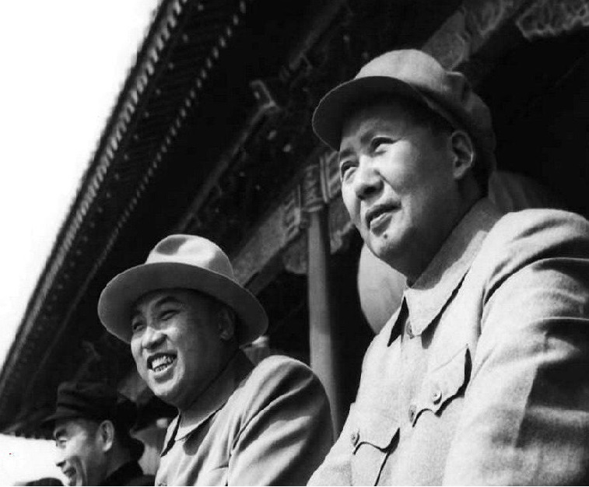
Kim II-Sung (center) and Mao Tse Tung in Beijing, 1954
Embracing state socialism as a means of “skipping over centuries of slavery and backwardness,” the Kim regime adopted an economic ideology centered on the concept of “juche,” or self-reliance, which helped to jumpstart economic development.[26] At the time of Korea’s liberation, over 90 percent of the industry in the former colony was owned by Japanese interests. The material resources for an egalitarian revolution were thus available. With the Japanese deposed, workers committees led predominantly by communists took control of most of the factories in the North. For a brief period, the Soviets seized control of the economy, including of the Wonsan Oil Company, and sent equipment, parts and the raw materials (including the oil) back to Russia as a “war prize.” After the North Korean People’s Committee was established in February 1946 , North Koreans retook charge and promulgated a law on nationalization of major industries which resulted in more than one thousand industries (90 percent of all of them in the North including electricity, transportation, railways and communications) becoming state property. By 1949, more than 50 percent of state revenue came from these nationalized industries, which helped finance the building of road infrastructure, schools and politicized universities as well as hospitals. The funds were also used to create a literacy program that reached over two million farmers.[27]
The DPRK’s crowning achievement was an expansive land reform campaign that was far less bloody than its counterparts in China and North Vietnam. According to U.S. Army intelligence, the land reform program “made 70 percent of the peasants’ ardent supporters of the regime,” although this total would later drop because of onerous taxation. Under the terms of the March 5, 1946 land reform law, all land owned by the Japanese government and Japanese nationals was confiscated along with land belonging to Korean landlords in excess of five chongbo (roughly twelve acres) and land rented out by landlords. Debts were also canceled. Nearly all of the confiscated land, which amounted to 980,000 chongbo, was redistributed to 710,000 peasant households for free, with less than 2 percent kept under state ownership. North Korea thus created a socialist economy in which major industries were under state control while most land was held by private households.
Based on the Maoist ideal of a society organized on the basis of collective social needs, Kim’s regime gained further support by promoting labor laws limiting working hours and providing collective bargaining rights as well as advancing women’s rights, passing laws to secure free rights in marriage and outlawing dowry exchange and child marriage. An editorial in a local newspaper asserted in 1947 that the “life of a North Korean woman today has been completely freed from subordination, domination, subservience and exploitation.”
Suzy Kim, in Everyday Life in the North Korean Revolution, 1945-1950, points to the importance of the people’s committees set up after liberation in spearheading revolutionary transformation. Though Kim Il Sung refused a UN supervised general election in the North in 1948, local elections were held for positions in which participation was high. Lt. Col. Walter F. Choinski, who was stationed in P’yongyang, likened them to the early 1900s in the U.S. in the level of excitement. He and other observers reported that the results were contested and that village meetings vetted candidates, ensuring that those who stood for office were popular and respected.[28] DPRK legitimacy was also bolstered after its formation through a purge of Japanese police officers linked to human rights atrocities.
The DPRK invested considerable resources into education and culture as an important vehicle in mobilizing support for the regime. Over one hundred writers had migrated from the South. Outside observers spoke of a “cultural renaissance” of native folk dancing, music, literature and drama. A nascent film industry was developed that celebrated the nationalist struggle against Japan. In late 1949, Kim Il Sung called on writers and artists to be “warriors who educate the people and defend the republic” and most importantly “portray the heroic struggle of the working people.” Pyongyang journalist Han Chaedok and novelist Han Sorya helped create a cult of personality surrounding Kim, modeled after Stalin and Mao. It proved to be long-lasting because it drew on Neo-Confucian tradition entailing respect for familial loyalty.

Part Three: Brutal anti-communist pacification in South Korea
Syngman Rhee was a conservative nationalist who lived in the United States for over four decades after being imprisoned by the Japanese as a young man. The Truman administration brought him back to Korea in October 1945 to lead the new South Korean government. Considering him a “Jeffersonian democrat,” the U.S. Office of Strategic Services believed that Rhee harbored “more of an American point of view than other Korean leader.”[34]
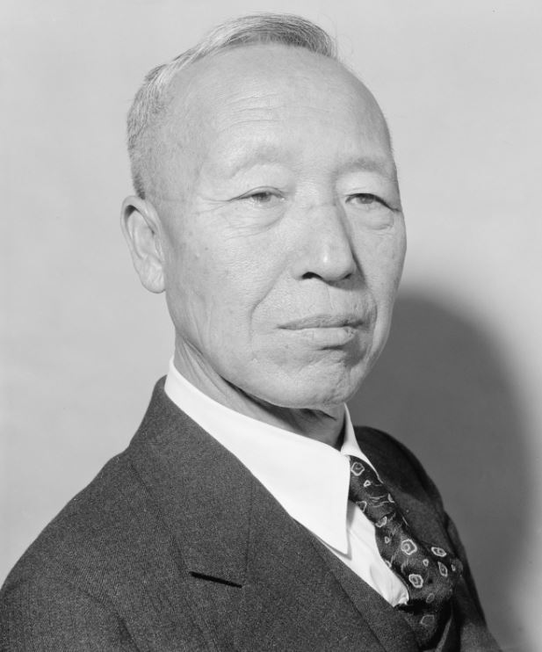
Syngman Rhee headed South Korea from its beginning in 1948 to his overthrow in 1960
In practice, Rhee exhibited strong autocratic and dictator tendencies and relied heavily on Japanese collaborators – in part because he had been out of the country so long. He was elected president in July 1948 by members of the National Assembly, who themselves had been elected on May 10 in a national election marred by boycotts, violence and a climate of terrorism. The elections were originally intended to be held in both the North and South, but Kim II-Sung refused to allow UN supervisors entry into North Korea. Some South Koreans boycotted the elections on the grounds that they would solidify the division between the Koreas, which is indeed what happened. Syngman Rhee proceeded to consolidate his rule thereafter. When asked by the journalist Mark Gayn whether Rhee was a fascist, Lieutenant Leonard Bertsch, an adviser to General John R. Hodge, head of the American occupation, responded, “He is two centuries before fascism—a true Bourbon King.”[35]
After formal establishment of the Republic of Korea (ROK) on August 15, 1948, Rhee refused to accept power sharing proposals to unify the north and south. Rhee also reinforced the economic status quo. According to Bruce Cumings, “The primary cause of the South Korean insurgency was the ancient curse of average Koreans – the social inequity of land relations and the huge gap between a tiny elite of the rich and the vast majority of the poor.” At the same time Rhee followed American dictates in passing a secret clause agreeing to export rice to Japan and signed contracts allowing American businesses to exploit the So Lim gold mine and take over the Sandong tungsten mine, which was guarded by U.S. troops.[36]
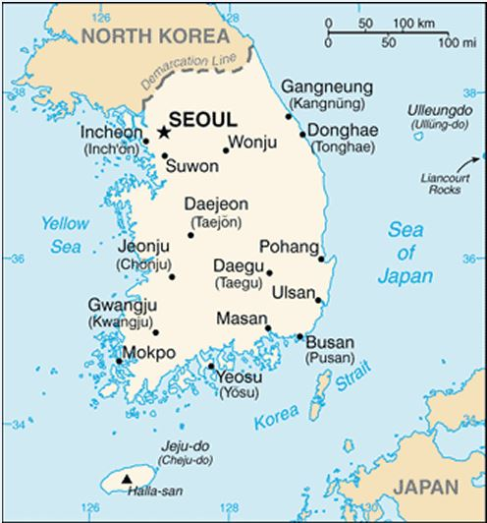
The Republic of Korea (south) was established on August 15, 1948
Political opposition to Rhee’s government emerged almost immediately when Rhee, with U.S. backing, retained Japanese-trained military leaders and police officers instead of removing them. Those who had resisted Japanese rule, administered with the aid of these collaborators, called for Rhee’s ouster. The communists in South Korea protested the loudest, as they had led the anti-Japanese insurrection, but opposition to Rhee was widespread. Resistance to the U.S. occupation and Rhee’s government was led by labor and farmers’ associations and People’s Committees, which organized democratic governance and social reform at the local level. The mass-based South Korean Labor Party (SKLP), headed by Pak Hon-Yong, a veteran of anti-Japanese protest with communist ties, led strikes and carried out acts of industrial sabotage.[37] Rhee responded by building up police and security forces and, with assistance from the American Military Government (AMG), attempting to eliminate all political opposition, which he labeled communist-backed. Thus, the earlier antagonism between rebels and collaborators during Japanese rule took on the dimensions of both a partisan struggle within South Korea and a struggle between North and South.
In October 1946, revolts broke out in South Cholla province, triggered by police abuse and the imposition of strict wage controls by occupation authorities. Riots in Taegu were precipitated by police suppression of a railroad strike that left thirty-nine civilians dead, hundreds wounded, and thirty-eight missing. Martial law was subsequently declared and 1,500 were arrested. Forty were sentenced to death, including SKLP leader Pak, who fled North. Over 100,000 students walked out in solidarity with the workers, while mobs ransacked police posts, buried officers alive, and slashed the face of the police chief, in a pattern replicated in neighboring cities and towns. Blaming the violence on “outside agitators” (North Korean support was in fact more moral than material) and the “idiocy” of the peasants, the American military called in reinforcements to restore order. The director of the U.S. Army’s Department of Transportation stated: “We had a battle mentality. We didn’t have to worry too much if innocent people got hurt. We set up concentration camps outside of town and held strikers there when the jails got too full…. It was war. We recognized it as war and fought it as such.”[38]
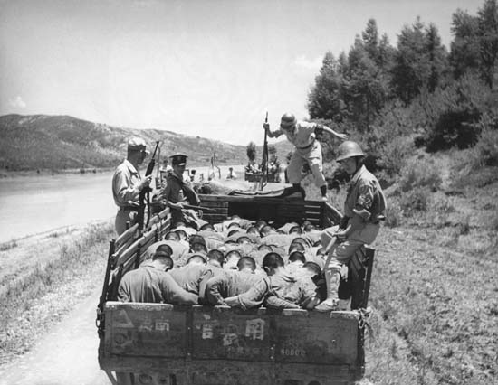
Suspected South Korean traitors fill the back of a truck, on their way to execution by South Korean security forces – Taeju, South Korea, 1950
By mid-1947, there were almost 22,000 people in jail, nearly twice as many as under the Japanese, with the Red Cross pointing to inadequate medical care and sanitation. Professors and assemblymen were among those tortured in custody. Those branded as communists were dehumanized to the extent that they were seen as unworthy of legal protection. Pak Wan-so, a South Korean writer who faced imprisonment and torture by police commented that “they called me a red bitch. Any red was not considered human…. They looked at me as if I was a beast or a bug…. Because we weren’t human, we had no rights.”[39] The scale of repression in South Korea at this time far surpassed that of North Korea. In Mokpo seaport, the bodies of prisoners who had been shot were left on people’s doorsteps as a warning in what became known as the “human flesh distribution case.”[40] A government official defended the practice saying they were the most “vile of communists.”
Similar brutality was displayed in the suppression of a popular insurrection in Yeosu which broke out in October 1948 after the 14th ROKA regiment refused orders to “murder the people of Cheju-do fighting against imperialist policy.”[45] Order was restored only after purges were enacted in the constabulary regiments that had mutinied under Hausman’s direction and the perpetrators were executed by firing squad. Much of the town was set on fire.[46]
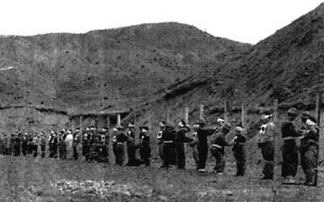
On April 14, 1950, ten miles northeast of Seoul, South Korean Military Police executed 39 Koreans suspected of being “communist”

Part Four: Bombing ‘em back to the Stone Age: Aerial techno-war over North Korea
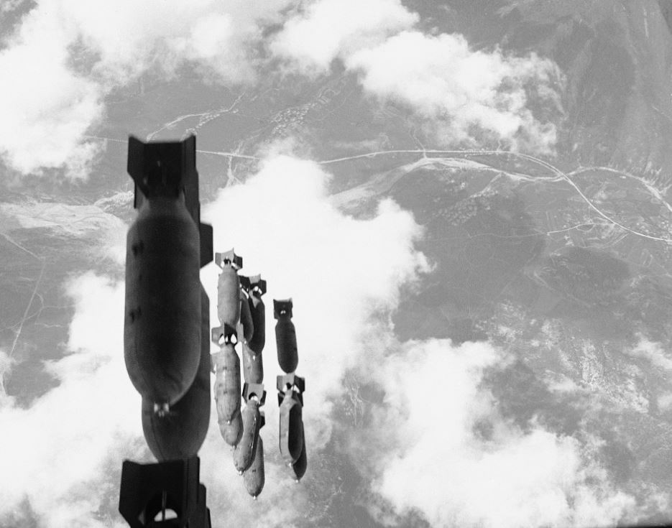
U.S. bombs fell on South Korea as well as on North Korea. Salvo of 500-pound bombs dropped from a U.S. B-29 on communist-controlled territory west of the Naktong River, Aug. 16, 1950 (AP photo)
The American Caesar, General Douglas MacArthur, was a boyhood friend of air power prophet Billy Mitchell, who had served under his father, Arthur, in the Philippines. Like Mitchell, Douglas MacArthur’s worldview had been shaped by the horror of the trenches of World War I and he had adopted the view that since war was so horrible, whoever unleashed it should be obliterated; and that, in a righteous cause, there was no substitute for victory.[129]
In the latter spirit, MacArthur had warned that if the Chinese intervened, “our air power will turn the Yalu River into the bloodiest stream in all of history,” which is not far removed from what happened.[130] From air bases in Okinawa and naval aircraft carriers, the U.S. Air Force launched over 698,000 tons of bombs (compared to 500,000 in the entire Pacific theater in World War II), making use of innovations like in-flight refueling systems, faster and more nimble engine-driven machines, and ground-radar controlled missions allowing for night bombing which Lt. Gen. Edwin M. Almond of X Corps called “an epic in our warfare.”[131]
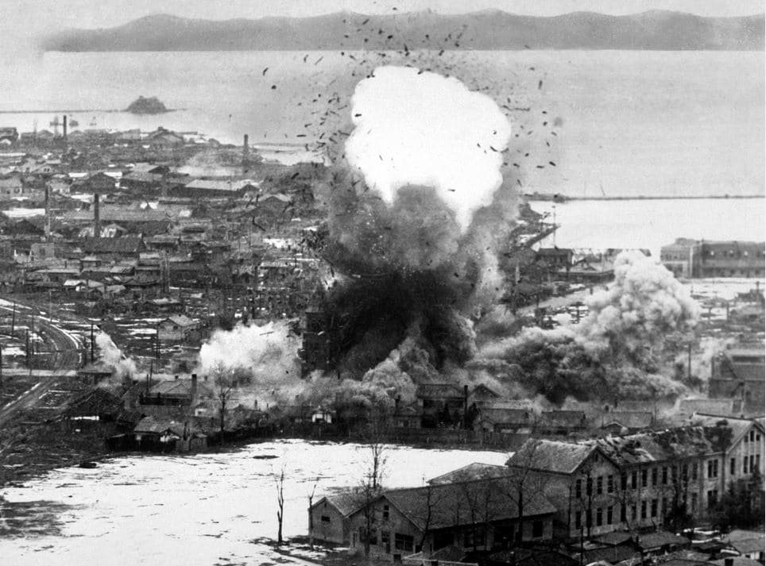
US Air Force bombers destroy warehouses and dock facilities in Wonsan, North Korea, 1951 (US Dept of Defense-USIA)
Much of North Korea was left, in Maj. Gen. Emmett O’Donnell Jr.’s words, a “terrible mess,” with thousands of Chinese slaughtered, an estimated one million civilian casualties and hundreds of thousands of refugees. Some of those refugees were napalmed by U.S. pilots under orders to “hit anything that moved.” Eighteen out of 22 cities were obliterated, including 75 percent of Pyongyang and 100 percent of Sinuiju. Gen. Curtis LeMay, head of the Strategic Air Command during the Korean War, later told an interviewer:
We slipped a note kind of under the door into the Pentagon and said, “Look, let us go up there…and burn down five of the biggest towns in North Korea – and they’re not very big – and that ought to stop it.” Well, the answer to that was four or five screams – “You’ll kill a lot of non-combatants,” and “It’s too horrible.” Yet over a period three years or so…we burned down every town in North Korea and South Korea, too… Now, over a period of three years this is palatable, but to kill a few people to stop this from happening – a lot of people can’t stomach it.[132]
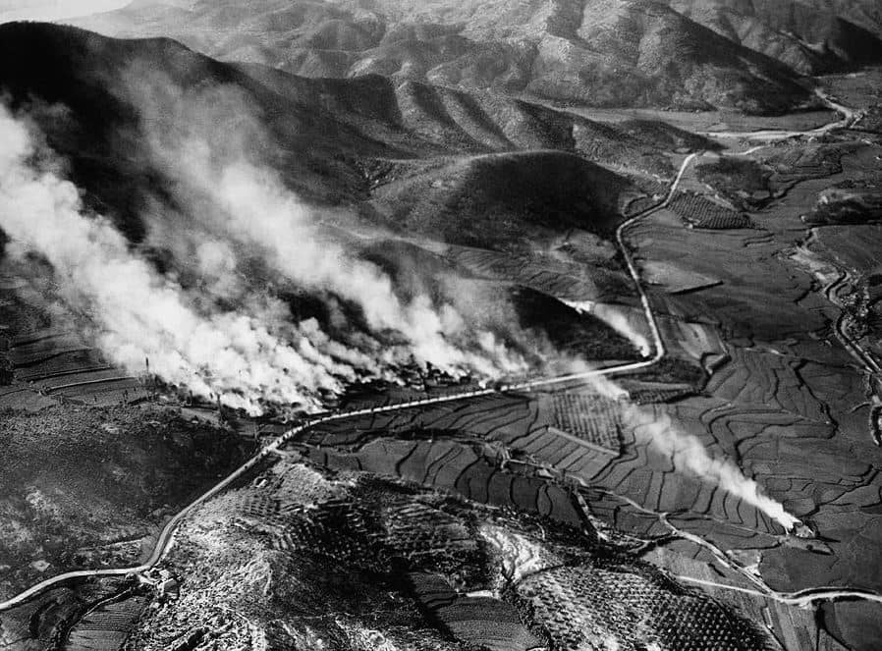
Village of Agok in northern region of North Korea hit with missiles, August 1950
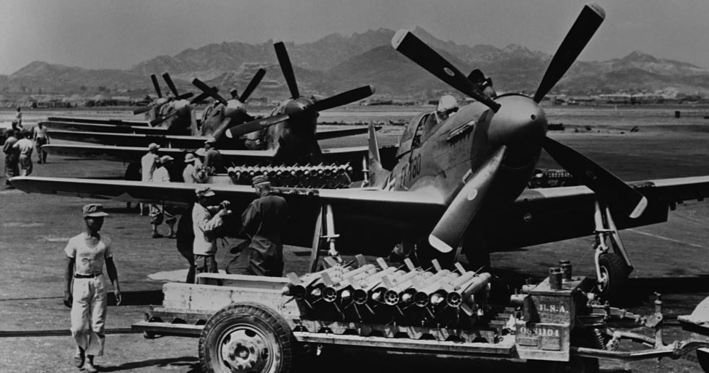
U.S. fighter aircraft loaded with rockets
Push-button warfare was directed predominantly at major industrial plants in North Korea as well as railroads, bridges, communications centers and the electrical grid. Schools and hospitals were also badly damaged or destroyed along with Kim Il Sung University, archeological sites, and treasured historical monuments such as the Kwangbop Buddhist temple dating to 392 A.D, the Potang City gate, the Sungryong Hall temple dating to 1429, and the Yang Myong temple dating to the 14thcentury.[142] DPRK leaders hid in deep bunkers, while villagers were forced to live in holes dug in the rubble of cities and sides of hills and caves where disease proliferated.
North Korean and Chinese fighters, like the Vietnamese, became adept at kneeling or squatting to evade detection. They wore camouflage uniforms in the summer and white jackets in winter to blend in with the snow.[143] They also built dummy airfields filled with dummy aircrafts and petroleum dumps, camouflaged buildings and gun positions, and built shelters for trucks to hide in during the day.[144] To protect civilians, North Koreans dug 776 miles of tunnels and 3,427 trenches, shifting 78 million cubic yards of rock and earth. Entire factories were moved underground, along with schools, hospitals, bridges and government offices. These practices enabled North Koreans to survive the massive bombing onslaught, though agriculture was devastated, as farmers could only tend to their fields at night. The Nodong Sinmun newspaper referred to 1951 as “the year of unbearable trials.”[145]
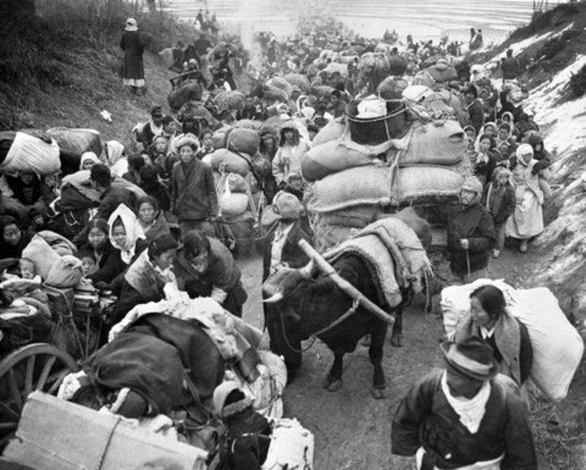
Battle-weary Korean civilians crowd a Korean road in late January 1951, seeking safety from the continuous fighting (UN Photo Archive).
Racial dehumanization was a pivotal factor accounting for the lack of American restraint in targeting civilians. MacArthur believed that “the Oriental dies stoically because he thinks of death as the beginning of life.” American bombers dropped thousands of leaflets warning civilians to stay off roads and away from facilities that might be bombed, but independent observers noted that American ground forces were much too “quick to call in overwhelming close air support to overcome any resistance in flammable Korean villages.”[146] Pilots were often under orders not to return with any bombs. According to Australian journalist Harry Gordon, who rode along in a B-26 Intruder, they would attack anything that moved, including ox-carts, resulting in “needless slaughter.”[147]
Mission reports at the U.S. National Archives provide a window into the detachment of the pilots and destructive effects of their operations. These records detail in terse professional language the number of buildings, industrial facilities or trucks damaged or destroyed by rocket, napalm, dive bombing and strafing attacks and note the killing of enemy troops and pack animals and starting of large fires which were left burning.[148]
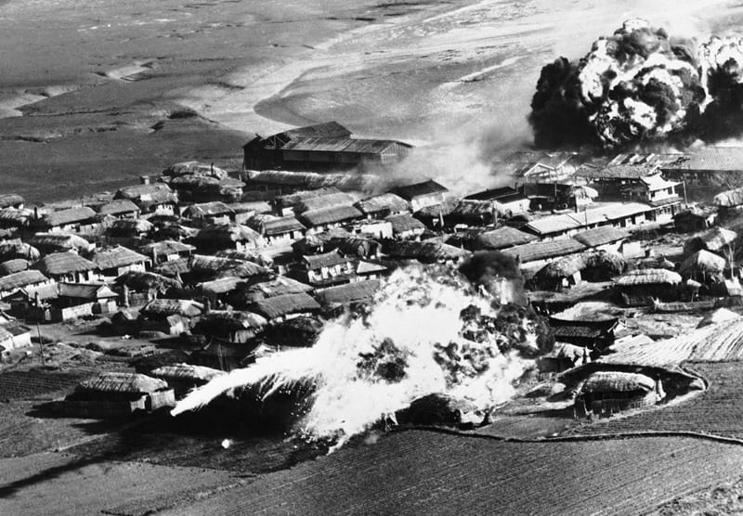
Thatched huts go up in flames after B-26 bombers unload napalm bombs on a village near Hanchon, North Korea, on May 10, 1951 (AP photo)
British journalist Reginald Thompson described “holocausts of death and jellied petroleum bombs spreading an abysmal desolation over whole communities. . . . In such warfare, the slayer merely touches a button and death is in the wings, blotting out the remote, the unknown people below.” The American investigative journalist I.F. Stone stated that sanitized reports of the air raids reflected a “gay moral imbecility utterly devoid of imagination – as if the flyers were playing in a bowling alley, with villages for pins.”[149] These comments presaged Herbert Marcuse’s 1964 book, One Dimensional Man, which warned that a cult of technical efficiency coupled with the quest for military-technological supremacy and antipathy towards foreign cultures had severed human connections and empathy in industrial capitalist societies, resulting in the kind of barbaric “machine” warfare seen in Korea and later, Vietnam.[150]
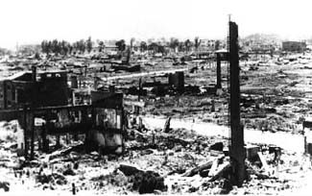
Pyongyang after U.S. bombing, 1953
Freda Kirchway, in an essay in The Nation, argued that American indifference to the destruction in Korea stemmed from the population having become “hardened by the methods of mass slaughter practiced first by Germans and Japanese and then, in self-defense, adopted and developed to the pitch of perfection at Hiroshima and Nagasaki. . . . We became accustomed to ‘area bombing,’ ‘saturation’ bombing, all the hideous forms of strategic air war aimed at wiping out not only military and industrial installations but whole populations.”[151]
As peace talks stalled in 1952, the Air Force destroyed the hydroelectric plant in Suiho that provided 90 percent of North Korea’s power supply. In blatant violation of the 1949 Geneva Convention on the Protection of Civilians in Time of War, Article 56, U.S. bombers subsequently struck three irrigation dams in Toksan, Chasan, and Kuwonga, then attacked two more in Namsi and Taechon. The effect was to unleash flooding and to disrupt the rice supply. An Air Force study concluded that “the Westerner can little conceive the awesome meaning which the loss of this staple commodity has for the Asian – starvation and slow death.” After the war it took 200,000 man days of labor to reconstruct the reservoir in Toksan alone. “Only the very fine print of the New York Times war reports mentioned the dam hits,” the historian Bruce Cumings notes, “with no commentary.”[152]

