PAPER 1 COGNITIVE APPROACH REVIEW SHEET
The following table is taken from “IB Psychology: A Revision Guide” (Link).
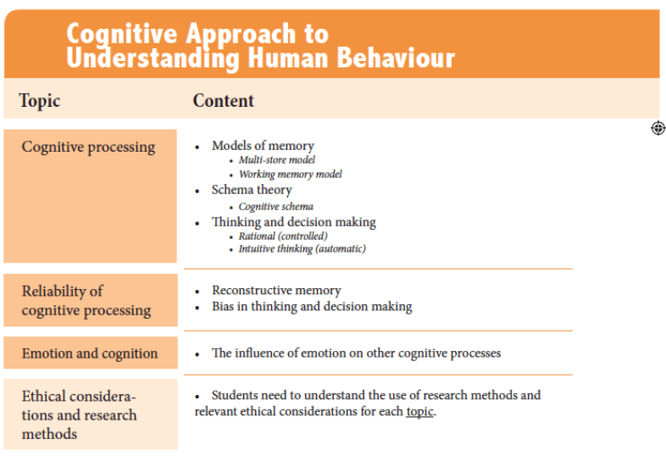
The exam questions will be based on the topic and content headings as shown above (Note: terms in italics will only be asked from May 2020 onwards).
Exam Questions
TOPIC | Content | SAQs | Essay Questions
Cognitive Processing | Models of memory | - Describe one model of memory.  - Outline one study related to one model of memory. | - Contrast two models of memory.  - Evaluate one model of memory.  - Evaluate one study related to one model of memory.  - Discuss models of memory.
 | Multi-store model | - Outline the multi-store model of memory. | SAQ term only
 | Working memory model | - Describe the working memory model.  - Explain how one study supports the working memory model. | SAQ term only
 | Schema theory | - Explain schema theory.  - Describe how one study relates to schema theory. | - Evaluate schema theory.  - Discuss one or more studies related to schema theory.
 | Cognitive schema | - Explain one study related to cognitive schema. | SAQ term only
 | Thinking and decision making | - Explain one theory or study related to thinking and decision-making.  - Describe one theory of thinking and decision making. | - Evaluate one theory or study related to thinking and decision-making.  - Discuss one theory of thinking and decision making.
 | Rational (controlled) | - Describe one example of rational (controlled) thinking. | SAQ term only
 | Intuitive thinking (automatic) | - Outline one example of intuitive (automatic) thinking. | SAQ term only
Reliability of cognitive processing. |  | - Outline one study on the reliability of one cognitive process. | - Discuss the reliability of one cognitive process.  - Evaluate one or more studies on the reliability of one cognitive process.
 | Reconstructive memory | - Explain one theory or study relevant to reconstructive memory.  - Describe how one study demonstrates reconstructive memory. | - Evaluate one theory or study relevant to reconstructive memory.
 | Bias in thinking and decision making | - Explain one bias in thinking and decision making.  - Explain how one bias in thinking and/or decision making can be shown in one study. | - Discuss one or more biases in thinking and decision making.  - Discuss one biases in thinking and decision making.
Emotion and cognition | The influence of emotion on cognitive processes | - Explain the influence of emotion on one cognitive process.  - Explain how one study demonstrates the influence of emotion on cognition.  - Explain how emotion may affect one cognitive process. | - Discuss the influence of emotion on one cognitive process.  - To what extent does emotion affect cognition?  - Discuss how emotion may affect one or more cognitive processes?
Research Methods & Ethical Considerations
Questions about research methods and ethics will be based on the three “topics” for the cognitive approach (cognitive processes, the reliability of cognitive processes and emotion and cognition).
Research Methods
Short Answer Questions
- Outline one research method used to study cognitive processes.
- Describe the use of one research method used to study cognitive processes.
- Explain how and why one research method is used to study the reliability of one cognitive process.
- Explain the use of one research method used in the cognitive approach to understanding human behaviour.
Essay Questions
- Discuss one research method used to study cognitive processes.
- Evaluate one or more research methods used to study cognitive processes.
- Evaluate the use of one research method used to study the reliability of cognitive processes.
- Evaluate how and why one research method is used to study the effects of emotion on cognition.
- Discuss the use of one or more research methods used in the cognitive approach to understanding human behaviour.
Ethical Considerations
Short Answer Questions
- Outline one ethical consideration related to studies on cognitive processes.
- Explain one ethical consideration relevant to studies on the effects of emotion on cognition.
- Explain one ethical consideration relevant to one study on the reliability of cognitive processes.
- Outline one ethical consideration related to studies in the cognitive approach to understanding human behaviour.
Essay Questions
- Discuss one ethical consideration relevant to studies on cognitive processes.
- Discuss one ethical consideration relevant to one study on the reliability of cognitive processes.
- Discuss ethical considerations relevant to research on the effects of emotion on cognition.
- Discuss one or more ethical considerations relevant to research on cognitive processes.
- Discuss one or more ethical considerations related to research in the cognitive approach to understanding human behaviour.

