"The Philosophy of Harold & Maude"
By Justin Heazlewood "Philosophical Currents in Cinema"
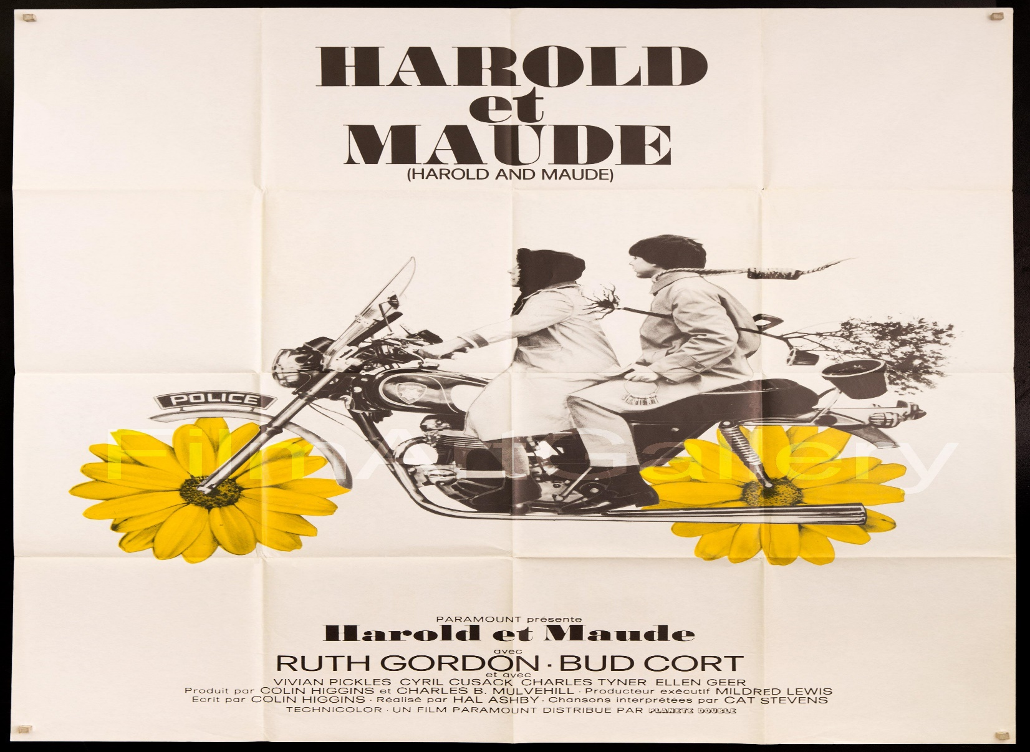

1971’s Harold and Maude is a twisted coming of age story and wildly eccentric romantic comedy. Harold is a deadpan and detached young man living in a mansion with his overbearing socialite mother. His favourite game is pretending to kill himself, either by hanging, fake blood in the bath or floating facedown in the swimming pool. His preferred pastime is attending funerals. It’s here that he meets Maude, a vivacious free spirit who steals cars and sees the world as her playground. She’s cheeky, beguiling and interested in Harold. She’s also seventy nine.
Thus begins this profoundly off-beat and darkly quirky tale, as Harold bounces between his suffocating home life and the dazzling dimension Maude paints for him. While his flabbergasted Mother enlists him in the army and sets him up on ‘computer dates’, Maude has him smoking hookahs, stealing police bikes and rescuing trees from the sidewalk. It’s delightful to see Harold’s transformation, as his menacing aloofness dissolves to a wide eyed wonder at this women from another planet.
Harold and Maude is a cinematic blueprint that certainly influenced many current movie directors such as the likes of Wes Anderson. Visually, it’s a feast; chocked with strong colours and dynamic compositions. Scenes open with dramatic panoramic shots, while the 70’s browns, greens and blues are captured in warm sepia tone. Just as Life Aquatic featured the songs of David Bowie, (and an appearance by Bud Cort) Harold and Maude is soundtracked by Cat Stevens. The bursts of studio recordings inject a warm energy and lightness to the story. In one memorable scene Maude struts through a graveyard with a yellow umbrella, backed by Tea For The Tillerman.The script is sharp and intelligent, mixing macabre physical comedy with snappy dialogue and some painfully optimistic philosophies. To off-set the wackiness, the film has an anti-war bent. Harold’s Uncle is a one armed Sergeant returned from Vietnam, pulling a drawstring to salute with his empty sleeve. To protest against this spiritual repression, Maude mentors Harold to be ‘impulsive and fanciful,’ and while some of her rants can grate, there’s some splendid exchanges.
Harold: Do you pray?
Maude: Pray? No, I communicate.
Harold: With God?
Maude: With Life.
On first viewing it’s easy to get caught up in the idiosyncratic humour and age politics. The film doesn’t shy away from this, and there’s a hilarious monologue from the priest warning Harold against ‘co-mingling with the withered flesh and flabby buttocks.’ Yet on second viewing the film reveals a deceptive emotional depth. In an easy to miss sequence, Maude uncovers a Jewish concentration camp tattoo. In this context, the pair singing If you want to sing out, sing out / If you want to be free be free passionately off-key, brought me close to tears.
In the end, however, this movie is a deep meditation of philosophy, life, and religion. This begins with the title "Harold and Maude" which can be interpreted as a version on "Yin and Yang" from the Taoist Philosophy. In this movie Harold is the Yang representing death, and Maude is the Yin representing Life. At first they might seem like opposites, but through the film we discover that they are one and the same. The Yin and the Yang complement each other, fall in love with each other, and only exist together as one.
From a religious perspective, many critics have praised the character of Maude as one of the only strong feminine spiritual characters on screen. In that sense, Harold can represent Christianity and other Western religions' philosophical views, which seem to have a preoccupation with death and the after-life. In sharp contrast, Maude can be seen as either a modern-day Taoist saint or a rebirth of an ancient Wiccan or Goddess Priestess which has a preoccupation not with death but more with life. In this way, Maude is the Taoist/Wiccan Priestess instructing Harold into her philosophy that reveres and celebrates all the miracles and rhythms of life and nature. This first begins as Maude tries to help Harold get in touch with all his 'physical senses' and the small miracles involved in sight, taste, sound, and touch. Next, Maude initiates Harold into the miracles of nature and life all around him and how the first step to spirituality is to get back in touch with the life and nature surrounding you. Finally, Maude instructs Harold that the next step of spirituality is to be completely free, open, and your true self. It is as if Harold's spirit has been dead and now Maude is resurrecting him back to life.
Like most great works of art Harold and Maude was not appreciated or well-received in its own lifetime, but over the years, it has become one of the greatest 'cult classic' movies of all time and has influenced scores of our greatest movie directors. Like all great art, Harold and Maude exists and can be enjoyed on multiple levels and improves with each viewing experience. On one level it is a celebration of rebellion, non-conformity, and the triumph of true love over all. But on another level it is one of the greatest meditations on philosophy in modern cinema.

