Primary Documents used on the Unit 6 Test
Note: You already know there is NO LONG ESSAY on your Unit 6 Test this year. You only have to do 4 of 5 short-answer questions AND ALSO the Primary Document Analysis Chart like always. You will have 4 of the following 6 options to choose from on your test. Even though you do not have to write an essay this year, you remember that questions 4 and 5 of the Primary Document analysis ask you to explain how you WOULD USE THIS DOCUMENT IF YOU WERE ANSWERING ONE OF THE FOLLOWING ESSAY QUESTIONS. So you still need to prepare for that.
So here are the 2 Essay Options you should refer to in your answer:
Essay Option A prompt: "The U.S.A. became fascist in order to defeat fascism in World War II.” Agree, disagree or modify this statement.

Essay Option B prompt: Which theory of The Cold War (USSR Menace, USA Imperialism, or Orwellian) do you most agree with and why?

Primary Sources for analysis & use for Essay Option A:

Primary Source 1A:
Actual Dr. Seuss Cartoon
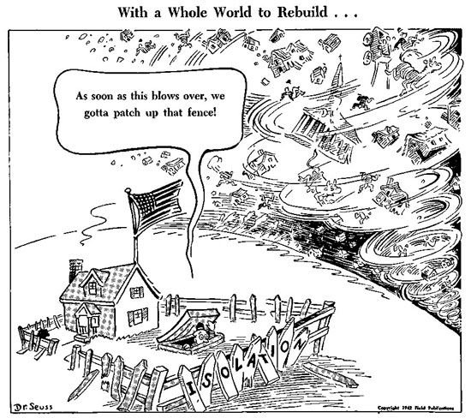

Primary Source 2A: Newspaper Headline Page from Manila, Phillippines
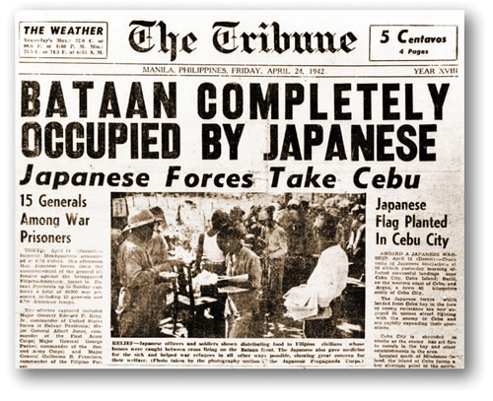

Primary Source 3A: A letter from Kenji Okuda to Norio Higano from Camp Harmony about his feelings on internment on Memorial Day,
"Dear Norio-sen
On this first Memorial Day after our fateful entrance into a frightening, devastating war . . . thousands of young Americans have already perished and other thousands are fighting furiously dying and killing . . . . there is nothing in this camp to remind us of that occasion except a memorial service this evening at 7. No military parade will we see; no valiant, half-hearted display of armed might . . . just a quiet service for those Japanese pioneers who have died striving that we, their children, might inherit something of that Great American ideal, Democracy.
But how futile and hypocritical this all sounds . . . in concentration camps in a Democracy . . . to be kept herein at the sole discretion of the military . . . and yet to be expected to be willing to do our best to insure the defeat of a nation with which so many of us are connected only by facial and racial characteristics."-

Primary Sources for analysis & use for Essay Option B:
Primary Source 1B: Political Cartoon by Henry Low in 1950
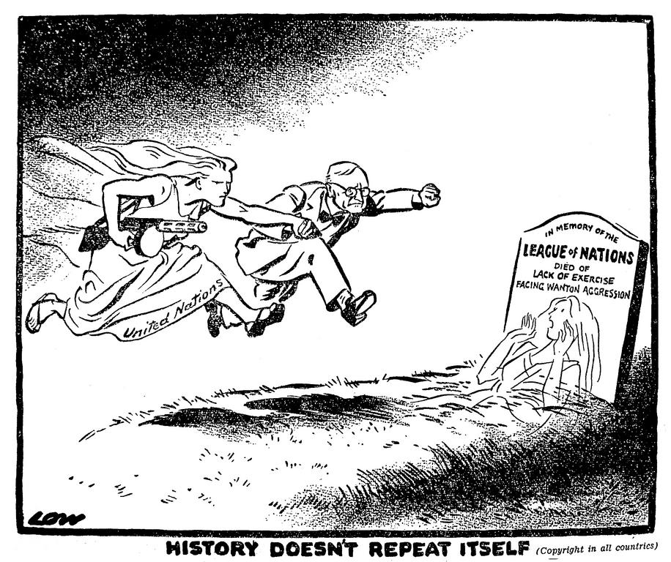

Primary Source 2B: Winston Churchill Speech
A shadow has fallen upon the scenes so lately lighted by the Allied victory…From Stettin in the Baltic to Trieste in the Adriatic, an iron curtain has descended across the Continent. Behind that line lie all the capitals of the ancient states of Central and Eastern Europe…All these famous cities and the populations around them lie in…the Soviet sphere, and all are subject in one form or another, not only to Soviet influence but to a very high and…increasing measure of control from Moscow.

Primary Source 3B: Political Newspaper Cartoon by Herbert L Block 1950. “The Big Push”
