PAPER 1 SOCIOCULTURAL APPROACH FINAL STUDY GUIDE
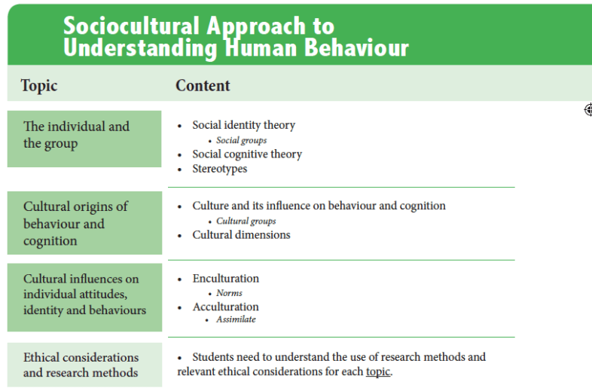
The exam questions will be based on the topic and content headings as shown above (Note: terms in italics will only be asked from May 2020 onwards). This table is taken from our new revision book (available here).
Exam Questions
TOPIC | Content | SAQs | Essay Questions
The individual and the group. | Social identity theory | - Describe social identity theory.  - Explain how one study supports social identity theory. | - Evaluate social identity theory.  - Discuss social identity theory’s explanation of human behaviour.  - Evaluate one or more studies related to social identity theory.
 | Social groups | - Explain how belonging to social groups can influence behaviour. | SAQ Only
 | Social cognitive theory | - Outline social cognitive theory.  - With reference to one study, explain social cognitive theory. | - Evaluate social cognitive theory.  - Evaluate one or more studies related to social cognitive theory.
 | Stereotypes | - Explain how stereotypes may influence human behaviour.  - Explain how and/or why stereotypes are formed. | - Discuss research related to stereotypes.  - Evaluate one study or theory related to stereotypes.  - Discuss the formation or effects of stereotypes.
Cultural origins of behaviour and cognition. | Culture and its influence on behaviour and cognition. | - Explain one influence of culture on behaviour.  - Explain one cultural origin of behaviour. | - Discuss one or more ways culture may influence behaviour and/or cognition.  - Discuss one cultural origins of behaviour.
 | Cultural groups | - Explain how belonging to cultural groups may influence behaviour and/or cognition. | SAQ Only
 | Cultural dimensions | - Explain the role of one cultural dimension in human behaviour.  - Outline one way cultural dimensions can influence behaviour. | - Discuss the influence of one cultural dimension on human behaviour.  - Evaluate one study related to cultural dimensions.
 |  | - Explain one cultural influence on individual behaviour. | - Discuss one or more cultural influences on individual attitudes, identity and/or behaviours.
Cultural influences on individual attitudes, identity and behaviours | Enculturation | - Explain one effect of enculturation on human behaviour.  - Outline one study related to enculturation. | - Discuss one or more effects of enculturation on human behaviour.  - Evaluate one or more studies related to enculturation.
 | Norms | - Outline one way cultural norms may influence human behaviour. | SAQ Only
 | Acculturation | - Describe one effect of acculturation on human behaviour. | - Discuss one or more effects of acculturation on identities, attitudes and/or behaviour.  - Evaluate one or more studies related to acculturation.
 | Assimilate | - Outline what it means to assimilate and how this may influence behaviour. | SAQ Only
Research Methods & Ethical Considerations
Questions about research methods and ethics will be based on the three “topics” for the sociocultural approach (the brain and behaviour, hormones and pheromones and behaviour and genetics and behaviour).
Research Methods
Short Answer Questions
- Outline one research method used to study cultural influences on behaviour.
- Describe the use of one research method used to study the individual and the group.
- Explain how and why one research method is used to study cultural origins of behaviour and/or cognition.
- Explain the use of one research method used in the sociocultural approach to understanding human behaviour.
Essay Questions
- Outline one research method used to study cultural influences on behaviour.
- Describe the use of one research method used to study the individual and the group.
- Explain how and why one research method is used to study cultural origins of behaviour and/or cognition.
- Explain the use of one research method used in the sociocultural approach to understanding human behaviour.
Ethical Considerations
Short Answer Questions
- Outline one ethical consideration related to studies on the individual and the group.
- Explain one ethical consideration relevant to studies on cultural origins of behaviour.
- Explain one ethical consideration relevant to one study on cultural influences on behaviour.
- Outline one ethical consideration related to studies in the sociocultural approach to understanding human behaviour.
Essay Questions
- Discuss one ethical consideration relevant to studies on the individual and the group.
- Discuss one ethical consideration relevant to one study on cultural origins of behaviour.
- Discuss ethical considerations relevant to research on cultural influences on behaviour.
- Discuss one or more ethical considerations relevant to research on cultural influences on behaviour.
- Discuss one or more ethical considerations related to research in the sociocultural approach to understanding human behaviour.
Notes
Paper One has two sections – A and B. In Section A you have three compulsory short answer questions, one from each approach (biological, cognitive and sociocultural). In Section B, you have three exam questions, also one from each approach and you answer only one. This means you should prep all core approach topics for SAQs and you can choose one approach for essays.
For short answer questions, because you can use the command terms interchangeably (outline, describe, explain) their selection for the above questions has been random.
The italicized terms above (e.g. norms) are the SAQ additional terms. It’s often difficult to predict how these will be phrased in IB exam questions. Also, these will not appear in the 2019 exams (May and Nov), but may appear in SAQs from 2020 onwards.
Disclaimer: These questions are not IB “official” questions and are written with our best guess as to what the probable exam questions may look like. Therefore, not every possible question is covered.

