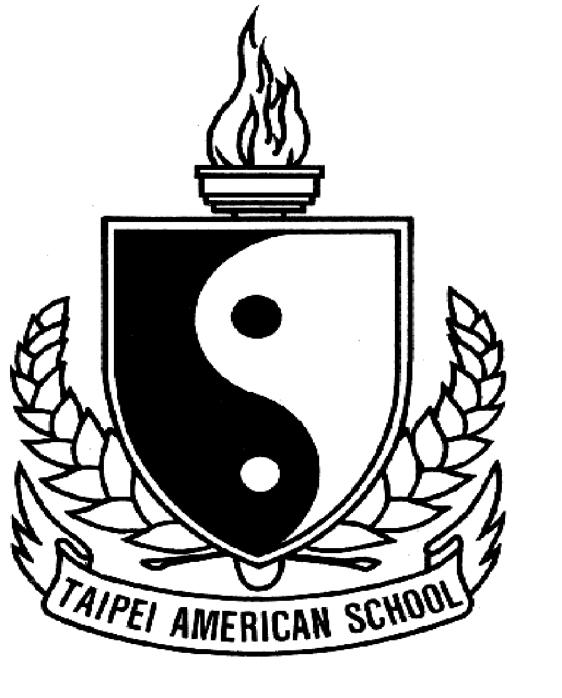
Taipei American School: World Religions 2022-23
Honors Seminar World Religions

Teacher: Mr. Chris Ciambarella
Email: ciambarellac@tas.tw
Class Website: www.mrciambarellaclass.com

2nd Semester Overview

This second semester will be very similar to the first semester; however, we will focus primarily on the 3 great Monotheistic Religions of Judaism, Christianity, and Islam. Like last semester, we will have a Socratic Seminar on each of these three religions for 30% of your grade. Another 30% of your grade will continue to be class participation because this is a SEMINAR-BASED CLASS!
What is NEW this second semester is that 40% of your grade will be an INDEPENDENT PROJECT. This will be a great opportunity for you to do in-depth study on anything you are interested in related to religion, philosophy, health, etc. In addition to working on these independent projects, we will also spend the first month of the semester exploring a "feminist" approach to religion and spirituality, in addition to exploring some other religions like Sikhism, aboriginal and indigenous religious systems and ideas.
COURSE GENERAL SCHEDULE
Semester II:
Unit 1 Work on your Independent Project
-Special study & discussion of "Feminine/Goddess" Spirituality & other religions
Unit 2 Judaism
Unit 3 Christianity
Unit 4 Islam

CLASSROOM EXPECTATIONS

Grading

Class Participation & Portfolio Work (30%)
After each class you will complete the "Class Participation Rubric", which can be found on my website under "Week 1 World Religions Participation Rubric." Please note that your class attention and participation will determine 30% of your overall grade! There will also be some in-class art portfolio work as well.

Socratic Seminars (30%)
Instead of quizzes, tests, and exams we have "Socratic Seminars". During these seminars students in the class are expected to prepare for and lead class discussions on assigned topics related to class. Part of your grade is your preparation and part of your grade is your participation.

Independent Project for Honors Students …or
Internal Study for non-Honors Students (40%)
I believe this project should be enjoyable for you!

For Honors & non-Honors students you may learn about anything related to World Religions, philosophy, world cultures, etc. I will pretty much accept any topic that you are passionate to learn more about! This is a great opportunity to read and learn about something you are interested in. Here are some examples from last year's topics:
Wiccan/Witch Practices Chinese Medicine Yoga & Meditation Practice
Sports & Mindfulness Music Styles in Religions Dancing in Religions
Taiwan Aboriginal Religions and Spirituality
Quantum Physics & Spirituality Bob Marley & Rastafarianism Science Fiction & Religion Learning Sanskrit Sufi Dancing
The Lord of the Rings Philosophy Chinese Calligraphy Tibet Culture

Of course, many students used this opportunity to learn more about any of the religions we are studying such as Hinduism, Buddhism, Christianity, etc.
Some students also decided to learn about other religions we did not cover, such as Japanese Shinto, Jainism, African Religions, Voodoo, etc..

WHAT IS THE DIFFERENCE AMONG HONORS vs. NON-HONORS STUDENTS?

NON-HONORS STUDENTS
The only difference is that for your Independent Project you are only required to research and read about it. You do NOT have to create a Final Project or Presentation. You are only graded on two things: 1)Your research and reading on the topic, and 2) A final "book report paper" about 3-5 pages long where you describe what you learned. It is NOT a research paper.

HONORS STUDENTS
For your Independent Project, you MUST have a FINAL PROJECT and also a FINAL PRESENTATION to the class. Or you can decide to make 1 VIDEO that counts as both your project and presentation.

World Religions 2022-23
Semester 2 Tentative Schedule

Dates  (in A/B order) | Topics
UNIT 1 | Independent Projects UNIT & Study of other ‘religions’ for fun
Jan 30  Day 1 | Work on Independent Projects  Sikhism
Feb 1  Day 2 | Work on Independent Projects  Sikhism
Feb 3  Day 3 | Work on Independent Projects  Aboriginal Religions
Feb 7  Day 4 | Work on Independent Projects  Into to Great Goddess Religion
Feb 9  Day 5 | Work on Independent Projects  Great Goddess Religion II
Feb 13  Day 6 | Work on Independent Projects  Wiccan & Modern Feminine Spirituality
Feb 15  Day 7 | Work on Independent Projects  Modern Feminine Spirituality
Feb 17  Day 8 | Work on Independent Projects
Feb 21  Day 9 | Work on Independent Projects
Feb 23  Day 10 | Work on Independent Projects
Feb 27  Day 11 | Work on Independent Projects
Mar 1  Day 12 | Work on Independent Projects
Mar 3  Day 13 | Work on Independent Projects
Mar 7  Day 14 | Work on Independent Projects
Mar 9  Day 15 | Work on Independent Projects
Mar 13  Day 16 | INDEPENDENT PROJECTS & PRESENTATIONS DUE!
UNIT 2 PD Day--No school for kids | JUDAISM
Mar 15  Day 1 | Judaism
Mar 17  Day 2 | Judaism
Mar 21  Day 3 | Judaism
Mar 23  Day 4 | Judaism
Mar 28  Day 5 | Judaism
Mar 30  Day 6 | Judaism
Apr 10  Day 7 | Judaism
Apr 12  Day 8 | SOCRATIC SEMINAR #1 on JUDAISM
UNIT 3 PD Day--No school for kids | CHRISTIANITY
Apr 14  Day 1 | Christianity
Apr 18  Day 2 | Christianity
Apr 20  Day 3 | Christianity
Apr 24  Day 4 | Christianity
Apr 26  Day 5 | Christianity
Apr 28  Day 6 | Christianity
May 3  Day 7 | Christianity
May 5  Day 8 | Christianity
May 9  Day 9 | Christianity
May 11  Day 10 | Christianity
May 15  Day 11 | SOCRATIC SEMINAR #2 on CHRISTIANITY
UNIT 4 PD Day--No school for kids CHRISTIANITY | UNIT 4 PD Day--No school for kids ISLAM
May 17  Day 1 | Islam
May 19  Day 2 | Islam
May 23  Day 3 | Islam
May 25  Day 4 | Islam
May 29  Day 5 | Islam
May 31  Day 6 | FINAL SOCRATIC SEMINAR OF THE YEAR!

