Iron Jawed Angels & Alice Paul Discussion
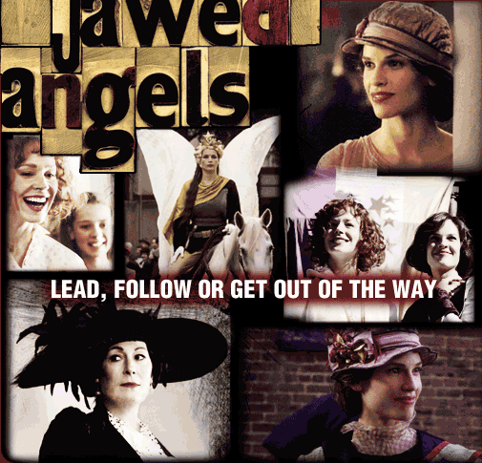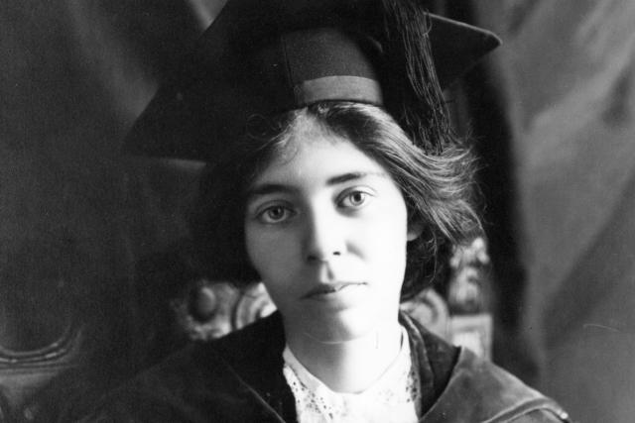
- What are your overall thoughts & reactions to the movie Iron Jawed Angels?

- What are at least 4 different forms of “nonviolent resistance”/ “Civil disobedience” that Alice Paul uses? Explain each one. Why was it effective or not effective? What are all the steps involved for each to be effective?

- Why can “public protest”-“nonviolent resistance” only work in a government with a democratic system of laws?

- What is the importance of “The Bill of Rights” (Amendments 1-10) in the ability for public protest/nonviolent resistance to be effective? How did you see it in the movie?

- What is the importance of “a free press” (news & media not controlled by the government & big business) in the ability for public protest/nonviolent resistance to be effective? How did you see it in the movie?

- Here is a quote from Gandhi (who was also a champion of nonviolent resistance/civil disobedience): “The purpose of a civil resistor is to provoke a response. We will continue to provoke until they change the law. It does not matter if they arrest me or arrest a thousand. They are not in charge. We are. That is the strength of civil resistance and why it is more effective than using violence.”

Explain what you think Gandhi means?
How do you see this in the movie Iron Jawed Angels?

- So, most people think that these methods of nonviolent resistance/civil disobedience were invented and first used by Gandhi and Martin Luther King, Jr. However, we now see that they were actually being used by Alice Paul and the Women’s Movement before Gandhi and Martin Luther King. What are your thoughts about this?

- Similarly, in 99% of USA History textbooks, the name Alice Paul does not even appear. What’s more in 99% of USA History books the 2 people given credit for passage of the 19th Amendment giving women the right to vote are : 1) President Woodrow Wilson and 2) NAWSA. What are your thoughts about this? How can the 2 people/groups that tried to stop Alice Paul and the push for women suffrage be given the credit for it? Why?

- Overall, why do you think 99% of Americans not even know who is Alice Paul? In my opinion, Alice Paul is one of the greatest reasons why girls and women have the freedoms they have today. Yet 99% of girls and women do not even know her name? WHY?

- How did it feel to study history from the viewpoint of women for 1- 2 weeks? Answer by gender:

- Young men- how did it feel to watch a movie of only women actors for 1-2 weeks?
- Young women- how did it feel to watch a movie of only women actors for 1-2 weeks?
- Now think about “History Class” the other 50 weeks of the year- What’s the effect of basically only studying men and men actors in history all the time? What effects does this have on girls, boys in school?

- After passage of the 19th Amendment- what are some other things Alice Paul devoted her life to?

- If Alice Paul was alive today, what would she be doing…
a)at your age in high school?
b)in college?
c) after college?

