Possible Primary Documents on Unit 2 Test
On the Unit 2 Test you will have an option of 2 essay questions and you pick 1 to answer.
Each Essay Option will have 2 primary documents related to it. So on your test you will only see 4 of these documents. But I can use any of them.

Primary Source 1:
"We the People of the United States, in Order to form a more perfect Union, establish Justice, insure domestic Tranquility, provide for the common defence, promote the general Welfare, and secure the Blessings of Liberty to ourselves and our Posterity, do ordain and establish this Constitution for the United States of America. . . .
…....Every Bill which shall have passed the House of Representatives and the Senate, shall, before it become a Law, be presented to the President of the United States[.] If he approve he shall sign it, but if not he shall return it, with his Objections to that House in which it shall have originated, who shall enter the Objections at large on their Journal, and proceed to reconsider it. If after such Reconsideration two thirds of that House shall agree to pass the Bill, it shall be sent, together with the Objections, to the other House, by which it shall likewise be reconsidered, and if approved by two thirds of that House, it shall become a Law. "

Primary Source 2:
Alexander Hamilton in The Federalist Papers
"All communities divide themselves into the few and the many. The first are the rich and well-born; the other the mass of the people. The voice of the people has been said to be the voice of God, and however generally this maxim has been quoted and believed, it is not true in fact. The people are turbulent and changing; they seldom judge or determine right. Give therefore to the first class a distinct permanent share in the government…Can a democratic assembly who annually revolve in the mass of the people be supposed steadily to pursue the public good? Nothing but a permanent body can check the impudence of democracy."

Primary Source 3:
Painting of the Signing of the US Constitution

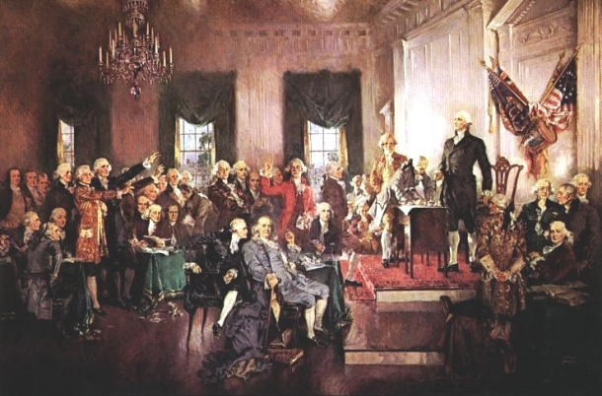

Primary Source 4:
Thomas Jefferson First Inaugural Address Speech as President
All, too, will bear in mind this sacred principle, that though the will of the majority is in all cases to prevail, that will to be rightful must be reasonable; that the minority possess their equal rights, which equal law must protect, and to violate would be oppression. Let us, then, fellow-citizens, unite with one heart and one mind. Let us restore to social intercourse that harmony and affection without which liberty and even life itself are but dreary things. And let us reflect that, having banished from our land that religious intolerance under which mankind so long bled and suffered, we have yet gained little if we countenance a political intolerance as despotic, as wicked, and capable of as bitter and bloody persecutions... But every difference of opinion is not a difference of principle. We have called by different names brethren of the same principle. We are all Republicans, we are all Federalists.
Primary Source 5:
Newspaper Political Cartoon about Thomas Jefferson (some historians say it might be Thomas Paine, but most say it is Thomas Jefferson)

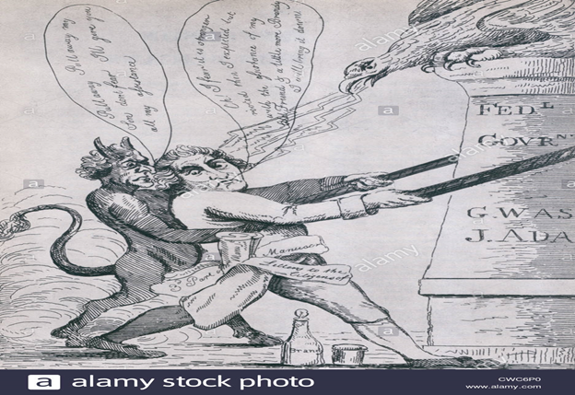

Primary Source 6: "Famous Whiskey Insurrection in Pennsylvania",

