Discussion of the movie Glory
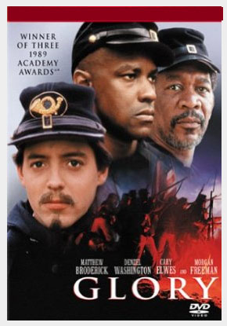
- What are your overall thoughts, opinions, reactions to the movie Glory?
- Why do you think President Lincoln (and many other historians) credit the 54th Massachusetts’ sacrifice at Ft. Wagner as “turning the tide of the Civil War” and even changing the country?

- How does each character change over the course of the movie?

- Colonel Robert Shaw
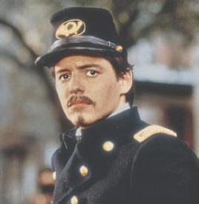

- Thomas (the free African-American & friend of Colonel Shaw from Boston who volunteers)
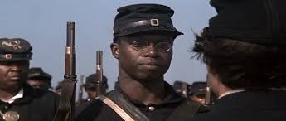

- Tripp (the runaway slave who is whipped for “deserting”)
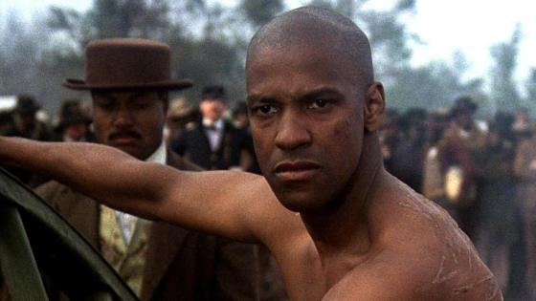

- The other Northern Union army white soldiers

- What is the meaning/symbolism of some of these final scenes from the movie?
- When Colonel Shaw- and then Tripp- sacrifice their lives by carrying the American flag up the side of the Fort in order to motivate the 54th to charge up the wall?
- The final scene when Colonel Shaw and Tripp are buried lying next to each other in the mass grave?

- In truth, this final scene really did happen. It was custom for each side to return Colonels and Sergeants killed in battle to the opposing side for them to receive a proper and honorable burial and funeral in their home. (Whereas they just put common soldiers in unmarked mass graves). However, the parents of Colonel Shaw said they did not want their son’s body returned, but they thought it was more honorable he was buried alongside the common soldiers of the 54th Massachusetts. Why do you think they said this? What are your thoughts about this?

- One of my favorite poems is by Robert Lowell and is about the 54th Massachusetts and Colonel Shaw. It is a famous poem and is called “For the Union Dead”. Let’s read it and discuss it.

For the Union Dead
Robert Lowell, 1917 - 1977

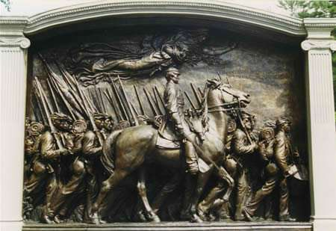

“Relinquunt Omnia Servare Rem Publicam.” (“They sacrificed everything to serve the Republic”)

The old South Boston Aquarium stands
in a Sahara of snow now. Its broken windows are boarded.
The bronze weathervane cod has lost half its scales.
The airy tanks are dry.

Once my nose crawled like a snail on the glass;
my hand tingled
to burst the bubbles
drifting from the noses of the cowed, compliant fish.

My hand draws back. I often sigh still
for the dark downward and vegetating kingdom
of the fish and reptile. One morning last March,
I pressed against the new barbed and galvanized

fence on the Boston Common. Behind their cage,
yellow dinosaur steamshovels were grunting
as they cropped up tons of mush and grass
to gouge their underworld garage.

Parking spaces luxuriate like civic
sandpiles in the heart of Boston.
A girdle of orange, Puritan-pumpkin colored girders
braces the tingling Statehouse,

shaking over the excavations, as it faces Colonel Shaw
and his bell-cheeked Negro infantry
on St. Gaudens’ shaking Civil War relief,
propped by a plank splint against the garage’s earthquake.

Two months after marching through Boston,
half the regiment was dead;
at the dedication,
William James could almost hear the bronze Negroes breathe.

Their monument sticks like a fishbone
in the city’s throat.
Its Colonel is as lean
as a compass-needle.

He has an angry wrenlike vigilance,
a greyhound’s gentle tautness;
he seems to wince at pleasure,
and suffocate for privacy.

He is out of bounds now. He rejoices in man’s lovely,
peculiar power to choose life and die--
when he leads his black soldiers to death,
he cannot bend his back.

On a thousand small town New England greens,
the old white churches hold their air
of sparse, sincere rebellion; frayed flags
quilt the graveyards of the Grand Army of the Republic.

The stone statues of the abstract Union Soldier
grow slimmer and younger each year--
wasp-waisted, they doze over muskets
and muse through their sideburns . . .

Shaw’s father wanted no monument
except the ditch,
where his son’s body was thrown
and lost with his “niggers.”

The ditch is nearer.
There are no statues for the last war here;
on Boylston Street, a commercial photograph
shows Hiroshima boiling

