The Beatles & Hinduism

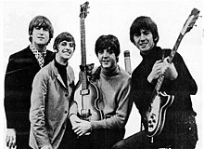
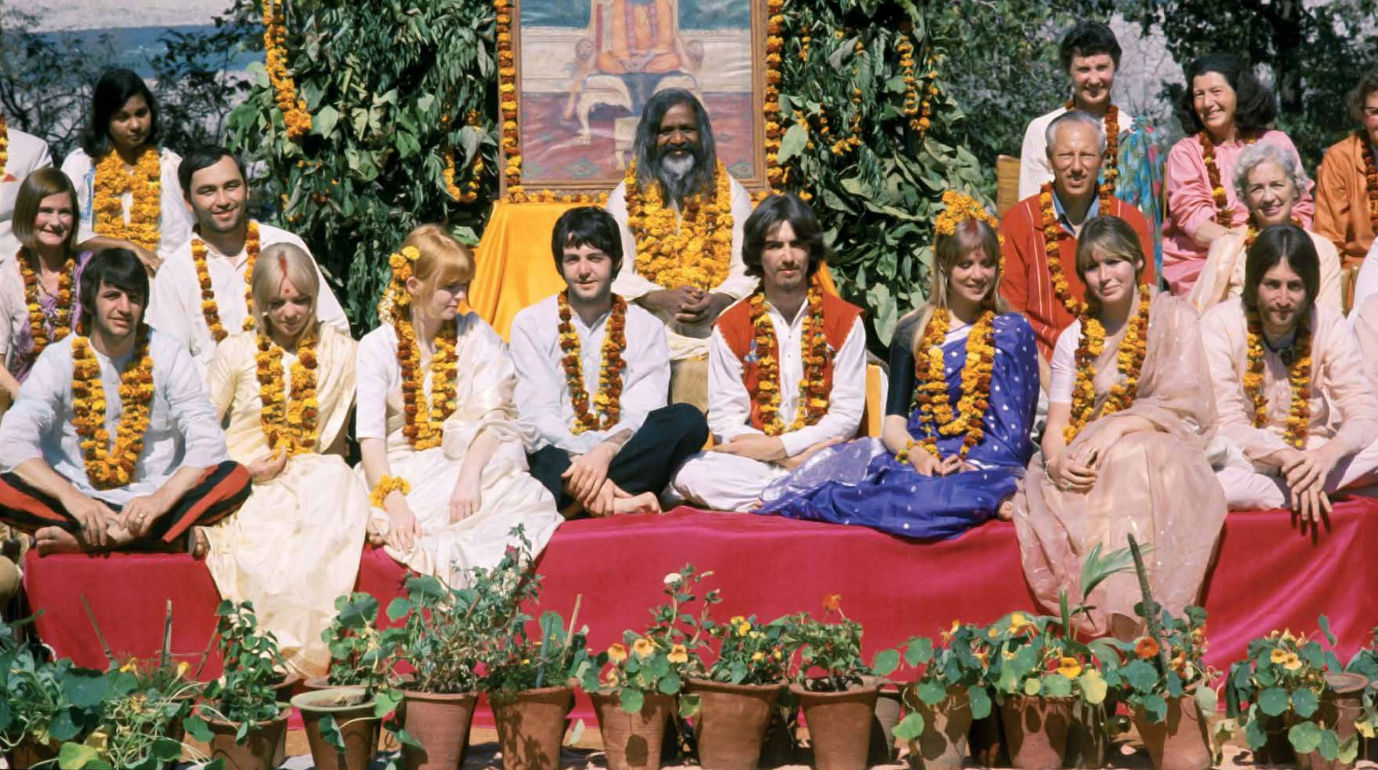

All You Need Is Love
The Beatles
Love, love, love
Love, love, love
Love, love, love
There's nothing you can do that can't be done
Nothing you can sing that can't be sung
Nothing you can say, but you can learn how to play the game
It's easy
Nothing you can make that can't be made
No one you can save that can't be saved
Nothing you can do, but you can learn how to be you in time
It's easy
All you need is love, all you need is love
All you need is love, love, love is all you need
All you need is love
All you need is love, love, love is all you need
There's nothing you can know that isn't known
Nothing you can see that isn't shown
There's nowhere you can be that isn't where you're meant to be
It's easy
All you need is love, all you need is love
All you need is love, love, love is all you need
All you need is love (All together now)
All you need is love (Everybody)
All you need is love, love, love is all you need
Love is all you need
Love is all you need
Love is all you need
Love is all you need
Love is all you need
Love is all you need
Love is all you need
Love is all you need
Love is all you need
Love is all you need
Love is all you need
Yesterday
Oh yeah
(She love you, yeah, yeah, yeah)
(She love you, yeah, yeah, yeah)

My Sweet Lord
My sweet Lord
Mm, my Lord
Mm, my Lord
I really want to see you
Really want to be with you
Really want to see you, Lord
But it takes so long, my Lord
My sweet Lord
Mm, my Lord
Mm, my Lord
I really want to know you
I really want to go with you
Really want to show you, Lord
That it won't take long, my Lord
(Hallelujah)
My sweet Lord
(Hallelujah)
My Lord
(Hallelujah)
My sweet Lord
(Hallelujah)
I really wanna see you
I really wanna see you
I really wanna see you Lord
I really wanna see you Lord
But it takes so long, my Lord
(Hallelujah)
My sweet Lord
(Hallelujah)
Mm, my Lord
(Hallelujah)
My my my Lord
(Hallelujah)
I really wanna know you
(Hallelujah)
I really wanna go with you
(Hallelujah)
I really wanna show you, Lord
That it won't take long, my Lord
(Hallelujah)
Mmm
(Hallelujah)
My sweet Lord
(Hallelujah)
My my Lord
(Hallelujah)
Mmm
My Lord
(Hare Krishna)
My my my Lord
(Hare Krishna)
My sweet Lord
(Krishna, Krishna)
Oohh
(Hare Hare)
Now I really wanna see you
(Hare Rama)
I really wanna be with you
(Hare Rama)
I really wanna see you Lord
But it takes so long, my Lord
(Hallelujah)
Mmmm
My Lord
(Hallelujah)
My my my Lord
(Hare Krishna)
My sweet Lord
(Hare Krishna)
My sweet Lord
(Krishna, Krishna)
My Lord
(Hare Hare)
Mmmm
(Gurur Brahma)
Mmmm
(Gurur Vishnu)
Mmmm
(Gurur Devo)
Mmmm
(Maheshwara)
My sweet Lord
(Gurur Sakshaat)
My sweet Lord
(Parabrahma)
My, my my Lord
(Tasmayi Shree)
My, my my my Lord
(Guruve Namah)
My sweet Lord
(Hare Rama)
(Hare Krishna)
My sweet Lord
(Hare Krishna)
My sweet Lord
(Krishna Krishna)

