Kali is the 3,000-year-old feminist icon we need today
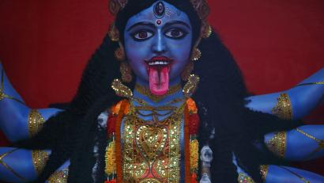
REUTERS/NAVESH CHITRAKAR
She is not afraid. Are you?

By Annalisa Merelli
Geopolitics reporter
January 8, 2020
Consider Kali, the Hindu goddess.
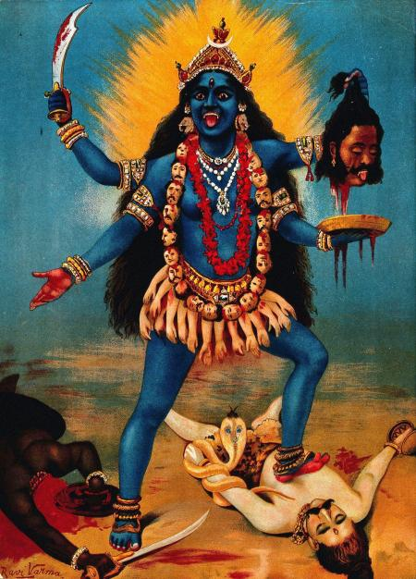
IMAGE BY RAJA RAVI VARMA VIA WIKIMEDIA COMMONS
A beauty.
Wild, naked, her tongue sticking out—an uncomfortable, feral image of force, bursting sheer power. She wears the most gorgeous jewellery—ornate bracelets and necklaces, and some amazing elephant-shaped earrings. There’s blood—that unsettling substance with which women are intimately familiar—everywhere on and around her: It drips from the severed head of a demon that she is holding up with one of her arms; it collects in the plate below it; it’s on her tongue, on the necklace of severed heads, and the skirt of ripped out arms which, alone, cover her nudity; it’s on a pool at her feet. There lies the beheaded demon, too, and next to it, her husband—Shiva, the destroyer, snake and all.
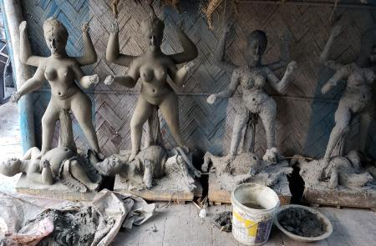
ANNALISA MERELLI FOR QUARTZ
Clay effigies of Kali being made in Kalighat, Kolkata.
Think about the clay effigies of Kali being handmade right by Kalighat Temple in Kolkata—some much bigger than a person, others miniatures—tongues out and arms out dancing: Can you picture a fiercer formation?
Kali embodies the boundless and existential freedom to be—without seeking permission.
She is a true monster, in that she is both frightening and awe-inspiring, beautiful in a way that isn’t in any way pretty—not shallow, not manageable, not comfortable. Kali, look at her, couldn’t care less if she is likable or not. She isn’t afraid of her force, and if you are, that’s on you. She isn’t the kind of deity that will easily be found sitting on a drawing room’s shelf, or hanging from a wall, with marigold garlands around her frame—and that’s just fine, for she’s got to slay.
Kali is the quintessential embodiment of shakti, female power. She emerges as an independent goddess around 1000 BCE and evolves as a controversial character: she is a scary, bloodthirsty embodiment of destruction, and the ultimate protector against evil. She is spiritual and bodily, erotic and sexual and as such, courageous: in the Tantrik cults that revolve around her, eroticism is primarily a way of confronting one’s deepest fears.
Arundhuti Singhal, the co-founder of the Mythology Project, a platform for analysis of mythology and folklore, notes that Kali’s ambivalent, and at time contradictory, nature is in line with her being an early female deity. Duplicity and multiplicity was a trait associated with female divinity in antiquity, she explains. Male gods have a single side—with the exception of Shiva, who has a complex nature because he contains both female and male natures—but, Singhal says, “you wouldn’t have a goddess standing for just one thing.”
Kali and other early female goddesses were the expression of nature. Like nature, she has a destructive side as much as a benevolent one. In this, she isn’t quite a devi, a full goddess, but shares the traits of what are known as asuras (demons, but just for lack of a better translation), different supernatural beings who don’t always have the ability to keep their passions under control. As a female, the power of creation rests with her; and as a female, too, so does the sheer force of nature.
This makes Kali the feminist icon we need today, in that she is a complex figure of many contrasting traits, all of which are equally worthy expressions of female strength—unapologetic because it doesn’t even consider that there could be anything to apologise for.
Kali’s role in the mythology vehicles a concept of femininity very different from the demure, graceful ideals that are mainstream the world around—including in India, the land that gave birth to this fierce goddess and yet prescribes the ideal woman as dutiful, submissive, obedient. Kali is none of that: Her power and ferociousness are greater than Shiva’s, whom she nearly kills by stomping upon him, an image so upsetting to the patriarchy that, explains mythologist Devdutt Pattanaik in Seven Secrets of the Goddess, it was long kept secret.
The myth wants her to be bloodthirsty and uncontrollable, while Shiva, the male god, is wise and in control: But this, Singhal notes, is just the male retelling of the story, shaped by centuries of patriarchal values.
There is another way to think about it, one in which the goddess is not trying to dominate Shiva—she is dancing, celebrating her victory against the demon, and got carried away. That is because, as Pattnaik notes, Kali’s force is pure nature, which “is indifferent to the human gaze.” Any intention and feeling we may project onto her are mere interpretations: She exists, strong and unbound from any of culture’s constrictions.
Kali’s femininity isn’t performative.
She represents nature at its rawest and most untamed. She is the culmination of all that is strength and power. She is loving without being devoted. She is the ultimate mother—the mother of all power—without being reduced to the role of a mother.
Kali’s femininity isn’t performative. She isn’t, like more manageable avatars of the female divinity such as Durga, or Parvati, calming, reasonable, submissive, or demure. But she doesn’t even have the traits that feminists old and new have seen, and loved, in her. She isn’t angry—although she is like fury—because nature knows no anger. She isn’t even wild, though her appearance rejects the constraints of culture. She is, simply, wilderness itself.
Choosing Kali as an icon isn’t reclaiming the right to be aggressive, feral, ugly, or merciless—it is embracing that the ultimate goal for which women continue to be at war is, simply, to be. Like Kali—whatever the human gaze may choose to see in it.

