Mr. C US History
2nd Semester 2023
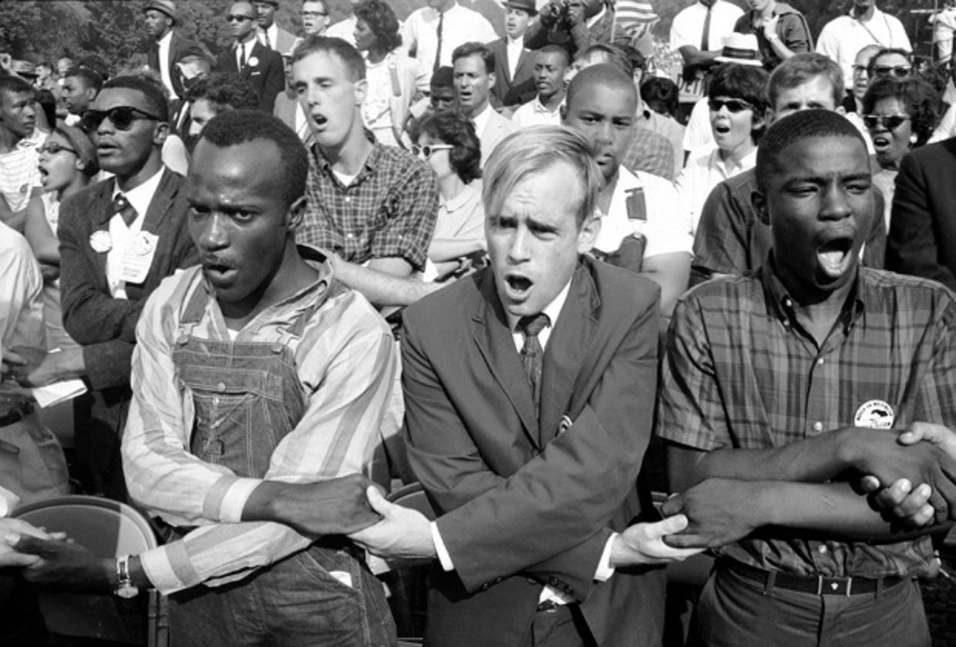 | 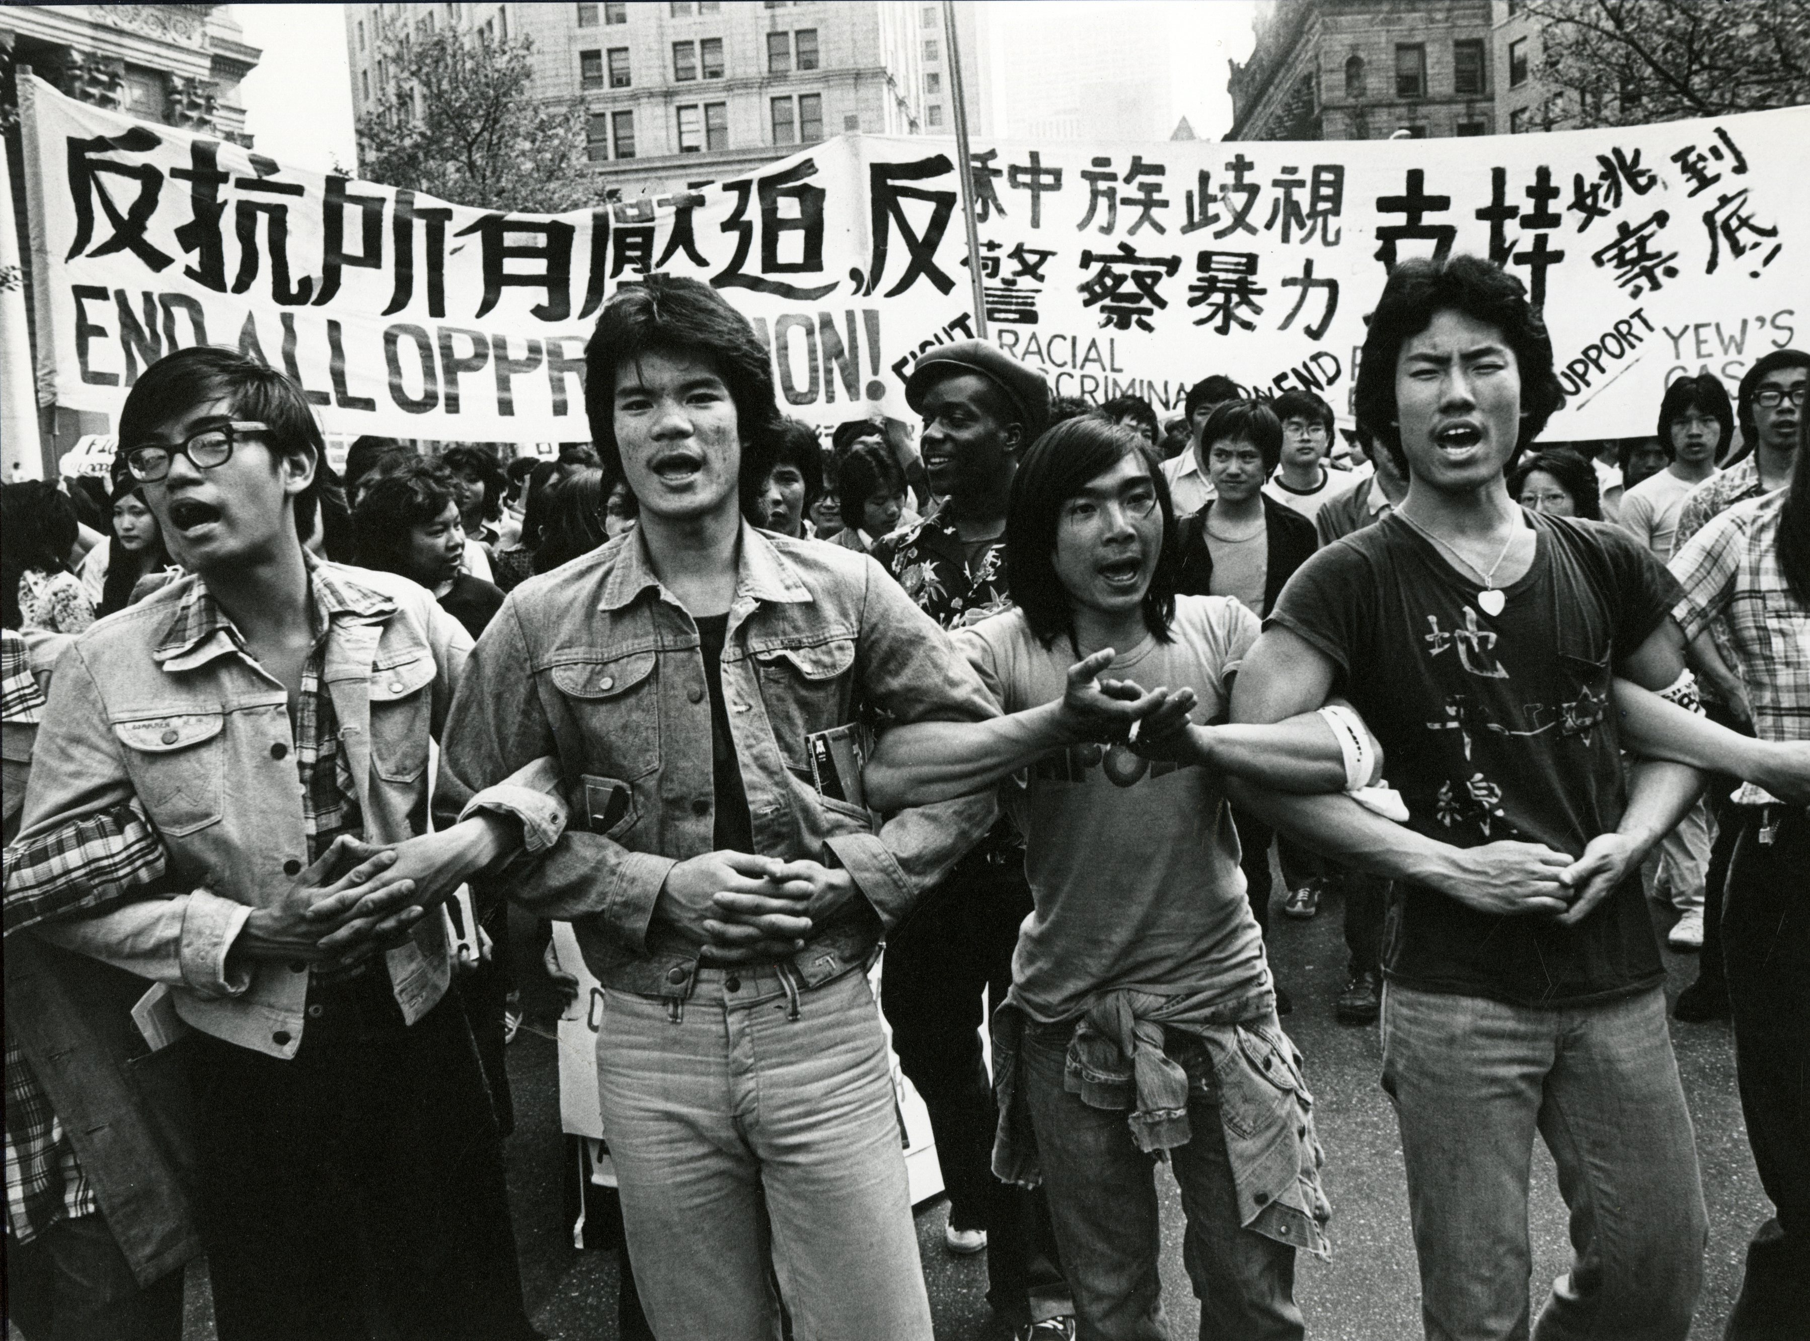

Welcome back! If you found US History in the 1st Semester interesting and important- which I hope you did- then be excited because 2nd Semester is even more interesting, important, and fun. These 2nd Semester Topics are my favorite and why I love to be a teacher. I'll even go so far to say that learning about topics such as the role of the students in the pictures above here in the 1960s US Civil Rights Movement may even be life-changing. I know it was for me. More than ever I hope you will see how these 2nd Semester topics relate directly to you and the kind of country and world you want to live in- and the important role you play in this story.

Brief Overview & Major Topics Covered:
Unit 5 WWI to the Great Depression
Unit 6 WWII to The Cold War
Unit 7 The Civil Rights Movements & 60s Protest/Counterculture
Unit 8 The Vietnam War to the War in Iraq
Unit 9 Group Project & Modern US History

2nd Semester Grade Breakdown:
20% Homework, Classwork & Participation
20% Research Paper
5% is the homework steps & rough drafts along the way
5% is your Final Research Notetracking Sheet
10% is the Final Research Paper
30% Tests
We have 3 Unit Tests (Unit 5, Unit 6, and Unit 8) each worth 10%.
Unit 5 and Unit 8 will be multiple-choice & short-answer tests.
Unit 6 will be an Essay Test.
30% Projects
We have 4 Projects
- 5% for Unit 5 Roaring 20's Dinner & Dance Party
- 5% for Unit 6 Debate on US dropping atomic bomb on Japan
- 10% for Unit 7 Mock Trial of Malcolm X
- 10% for “Final Exam” Group Project on Unit 9 Material (we do this final exam group project instead of a 2nd semester final exam!)

Two Final Thoughts about the 2nd Semester:

- Why are we doing this?
Answer: this is college-prep.
-The majority of your social sciences college classes your first 2 years of college have the same requirements for your grade: A Midterm and Final Exam & 1 Research Paper.
-This largely determines your entire grade for college! College classes assume that you already know how to do well on these: 1)You already know how to learn material by yourself and do well on a midterm and final exam. Most of your midterm and final exam involves writing long essays, and 2) You already know how to write an advanced research paper by yourself.

- College-Recommendation Letters
I wrote over 50 college recommendation letters this year for students who took my US History class. Do you know what I did NOT write about in these letters? I did NOT write about your test scores or grades.
Do you know what I DID write about?
- I wrote about your attitude in class. Do you pay attention in class? Do you participate in class discussions? Do you answer questions? Are you excited to come to class and talk about US History?
- I wrote about your Projects. Did you get excited about any projects this year? Did you do something creative and interesting? Did you show real passion and excitement for your projects?
- I wrote about your Research Paper. Did you get excited about your research paper? Did your research paper reveal your passion and excitement for learning, studying, and scholarship.

Of course, colleges want to know that you got good grades on tests; however, more important is colleges want to know about your excitement and attitude towards learning and how you demonstrate that passion in your projects and papers.

