**New Deal Political Cartoons**

**Cartoon #1**

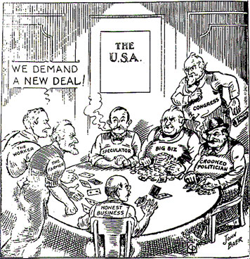

**Cartoon #2**

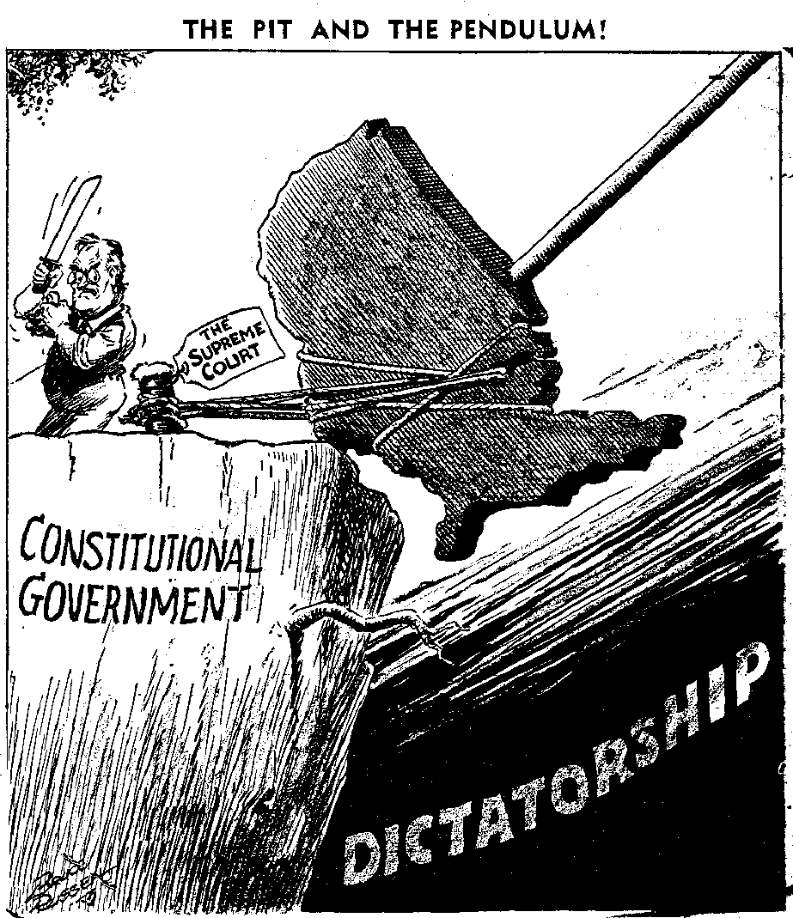

**Cartoon #3**

