Unit 1 Test Practice
Analyzing and Using Primary Source Documents
Remember on the Unit 1 Test you will write 1 Long Essay worth 70% of your grade.
You will have a choice of 2 possible Essay questions.
For each Essay Question choice you will be given 2 primary documents.
You MUST choose 1 of the primary documents to ANALYZE and then USE in your essay.
You MUST complete the Primary Document Analysis Chart for 10 points!!!
For example:

Essay Question Option: The main cause of The American Revolution was economics. Agree, disagree, or modify this statement.
Primary Document Given:
"We hold these truths to be self-evident, that all men are created equal, that they are endowed by their Creator with certain unalienable Rights, that among these are Life, Liberty and the pursuit of Happiness. — That to secure these rights, Governments are instituted among Men, deriving their just powers from the consent of the governed, — That whenever any Form of Government becomes destructive of these ends, it is the Right of the People to alter or to abolish it, and to institute new Government, laying its foundation on such principles and organizing its powers in such form, as to them shall seem most likely to effect their Safety and Happiness." July 4, 1776 Thomas Jefferson
You must complete this Primary Document Analysis Chart for 10 points:
- What is the SUBJECT of this document?
1-2 sentences
What is the #1 MAIN IDEA?

- What is the OCCASION of this document?
1-2 sentences
When was it written? What was going on when it was written?

- What was the PURPOSE of this document?
1-2 sentences
Who created it and why?

- What is the SIGNIFICANCE of this document?
2-3 sentences
How does it relate to the essay question?
How can it be used as evidence?

Picture Example:
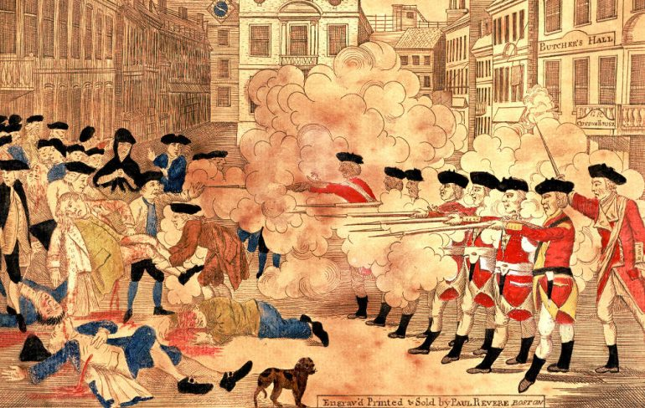
- What is the SUBJECT of this document?
1-2 sentences
What is the #1 MAIN IDEA?

- What is the OCCASION of this document?
1-2 sentences
When was it written? What was going on when it was written?

- What was the PURPOSE of this document?
1-2 sentences
Who created it and why?

- What is the SIGNIFICANCE of this document?
2-3 sentences
How does it relate to the essay question?
How can it be used as evidence?

