Test Primary Document Interpretation of Thomas Jefferson
30 points out of total 80 points on Unit 2 Test
For Example:
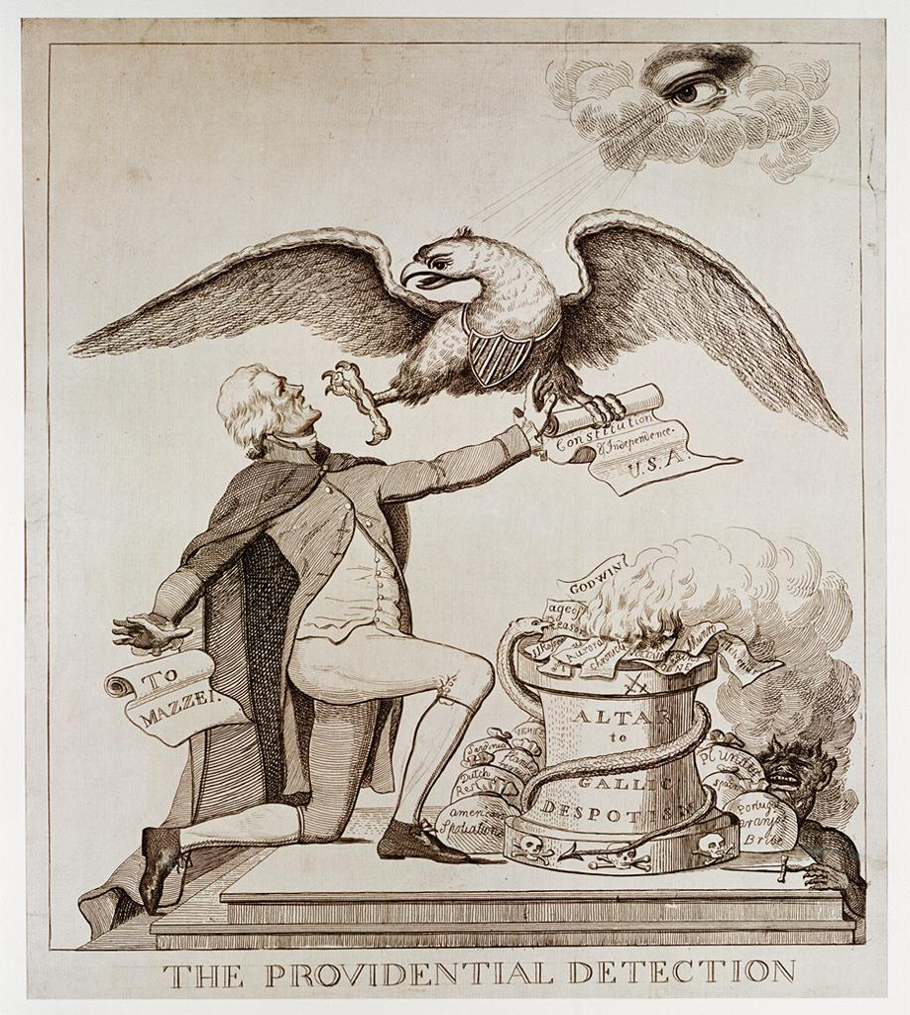

Question #1 (5 points)
What was the purpose of this cartoon or reading?

Question #2 (5 points)
Explain in complete sentences what words or parts of the poster or reading support your answer to the first question.

Question #3 (10 points)
Put that poster or reading into historical context-why would it have appeared when it did? You must say when it appeared. Use contextual clues to figure that out. What is happening in History when this document appeared & how does this document fit into that History? (What is going on 'before' & 'during' this document?)

Question #4 (10 points)
From what you know about the History we have studied, what evidence can you give to support the success or failure of the poster's or reading's purpose? (What happens 'next' in History?)

