Reflecting on the 1960s- Civil Rights, Vietnam Protest, & Social Movements
Debate: How should we assess and understand the 1960s? Does it prove the greatness of American Democracy or its opposite?
Point #1: 1968 was the Year the Dream Died
1968 proved that all the progress and excitement of the Civil Rights Movement, Vietnam War Protest, and 1960s Social Movements for greater equality for women and minorities eventually failed. The deaths of Martin Luther King, Jr. and Robert Kennedy clearly revealed the USA was not ready for this continued trend toward expanding democracy, equality, and peace for all. Instead the 1970s and 1980s saw the rise of the Conservative Right in the USA, which was a clear rejection of the Civil Rights Movement and 1960s Social Movements goals for the USA.
Point #2: Abbie Hoffman Final Speech Quote:
In the nineteen-sixties, apartheid was driven out of America. Legal segregation — Jim Crow — ended. We didn't end racism, but we ended legal segregation. We ended the idea that you can send a million soldiers ten thousand miles away to fight in a war that people do not support. We ended the idea that women are second-class citizens. Now, it doesn't matter who sits in the Oval Office. But the big battles that were won in that period of civil war and strife you cannot reverse. We were young, we were reckless, arrogant, silly, headstrong … and we were right! I regret nothing!
- Closing words from his last speech, Vanderbilt University (April 1989).

Point #3: How the 1960s cured America
By Charles Kaiser, Special to CNN
Editor's note: Charles Kaiser is the author of "1968 In America" and "The Gay Metropolis," a former reporter for The New York Times and The Wall Street Journal and a former press critic for Newsweek. He blogs about politics and the press for the Sidney Hillman Foundation.

"It is possible to read the history of this country as one long struggle to extend the liberties established in our Constitution to everyone in America."
-- Molly Ivins, great American newspaperwoman

Forty years after they ended, the 1960s remain the most controversial decade of the 20th century. Either you believe that they destroyed America, or they cured it.
Put me down as a fervent believer in their success as a cure.
Before 1960, only undivorced white Protestant men had ever served in the White House. Almost 100 years after the Emancipation Proclamation, African-Americans lived in segregated communities and attended segregated schools on both sides of the Mason-Dixon Line, and none attended the all-white state universities of the South.
Gay people were completely invisible, except when they were fired from the federal government (or any company doing business with the federal government, where they were also banned from employment.)
There were no openly gay journalists, doctors, lawyers or professors and only two openly gay public figures in the whole country: James Baldwin and Allen Ginsberg.
Women were denied abortions; in many states they could not buy contraception devices, or obtain national credit cards, or hope to rise to the top of most professions.
The young African-Americans who began the modern civil rights movement in the 1950s provided the model that would change the way everyone in America was treated who was neither white nor straight nor male.
It was the decision of these black men and women to reject the submissive roles white men had reserved for them that legitimized the aspirations of every other victim of oppression.
The movement that came of age in the early 1960s integrated universities, spurred the passage of the Civil Rights Act of 1964 and the Voting Rights Act of 1965, put black faces on TV shows that weren't sports contests and -- most importantly -- provided the blueprint for the liberation of every other oppressed group in the United States.

In no other period of our history did we make such dramatic progress in that never-ending struggle "to extend the liberties established in our Constitution to everyone in America."

The straight sexual revolution sparked by the birth control pill led rapidly to an unprecedented movement toward gay liberation -- partly because the pill had fueled the argument that sexual activity unrelated to procreation was just as useful and important as the other kind is.
The 1950s are often celebrated as the glory days of the postwar period, and in one sense they were, because America still had the most powerful industrial base in the world, propelling millions of Americans into the middle class.
But in every other way they were a period of sterile conformity, when monsters such as Sen. Joe McCarthy of Wisconsin launched witch hunts against mostly imaginary communists, and the federal government fired thousands of employees just because they were gay.
Or, as Hodding Carter put it to historian Arthur Schlesinger, when Schlesinger asked why Southern white men hated Bill Clinton so much, "They look back with longing at the good old days -- the days when abortion was in the back alley, gays were in the closet, women were in the kitchen, blacks were in the back of the bus, and condoms were under the counter."
A significant factor in all of this progress was the fact that organized religion -- and all of the prejudices and superstitions it embodied -- was at one of its lowest ebbs in our history.
That's the social and political side. Then there's the cultural side.
The liberation that was occurring at the polling places and universities was mirrored elsewhere when Aretha Franklin, Marvin Gaye, Diana Ross and scores of other black entertainers were suddenly just as famous and successful as Perry Como and Frank Sinatra.
The music produced in that era by Bob Dylan, Berry Gordy, the Beatles, Jimi Hendrix, the Byrds, the Beach Boys and hundreds of others will endure forever as my generation's proudest artistic achievement.
The Vietnam War was the decade's greatest tragedy -- a completely unnecessary adventure that killed 55,000 Americans and hundreds of thousands of Vietnamese. But those Americans did not die in vain -- because of their sacrifice, the Vietnam syndrome was born.
Wrongly maligned by neoconservatives, this was the syndrome that prevented us from repeating anything like that on a similar scale for more than 30 years -- until George W. Bush and his henchmen embarked upon the equally disastrous and unnecessary invasion of Iraq.

The idealism embodied by John and Robert Kennedy and the Martin Luther King Jr. inspired a whole generation to change the way America was governed, and how millions of Americans would get to live their lives.

Our single greatest failure was to sustain the idea that corporate America is the biggest threat to a vibrant democracy, and today the power of corporate wealth over our politics has never been more absolute.
But unless you truly believe that America was a better place when 99 percent of the positions of power were reserved for straight white men, you cannot deny that the '60s did more to improve our republic than any other era in our history.

Point #4: Robert Kennedy Quote:
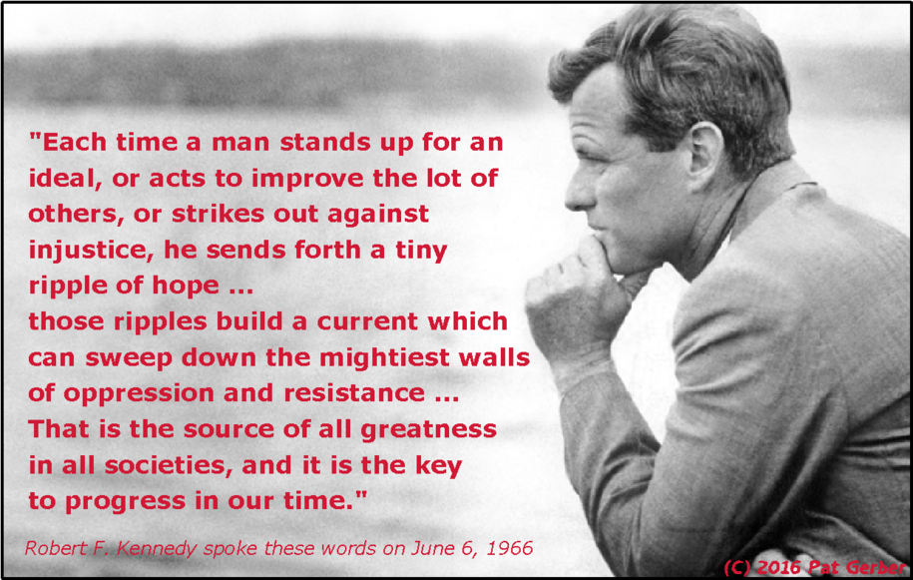

Point #5: "American Pie" by Don Mclean
A long long time ago
I can still remember how
That music used to make me smile
And I knew if I had my chance
That I could make those people dance
And maybe they'd be happy for a while
But February made me shiver
With every paper I'd deliver
Bad news on the doorstep
I couldn't take one more step
I can't remember if I cried
When I read about his widowed bride
Something touched me deep inside
The day the music died
So
Bye, bye Miss American Pie
Drove my Chevy to the levee but the levee was dry
And them good ole boys were drinking whiskey and rye
Singin' this'll be the day that I die
This'll be the day that I die
Did you write the book of love
And do you have faith in God above
If the Bible tells you so?
Do you believe in rock and roll?
Can music save your mortal soul?
And can you teach me how to dance real slow?
Well, I know that you're in love with him
'Cause I saw you dancin' in the gym
You both kicked off your shoes
Man, I dig those rhythm and blues
I was a lonely teenage broncin' buck
With a pink carnation and a pickup truck
But I knew I was out of luck
The day the music died
I started singin'
Bye, bye Miss American Pie
Drove my Chevy to the levee but the levee was dry
And them good ole boys were drinking whiskey and rye
Singin' this'll be the day that I die
This'll be the day that I die
Now, for ten years we've been on our own
And moss grows fat on a rolling stone
But, that's not how it used to be
When the jester sang for the king and queen
In a coat he borrowed from James Dean
And a voice that came from you and me
Oh and while the king was looking down
The jester stole his thorny crown
The courtroom was adjourned
No verdict was returned
And while Lennon read a book on Marx
The quartet practiced in the park
And we sang dirges in the dark
The day the music died
We were singin'
Bye, bye Miss American Pie
Drove my Chevy to the levee but the levee was dry
Them good ole boys were drinking whiskey and rye
And singin' this'll be the day that I die
This'll be the day that I die
Helter skelter in a summer swelter
The birds flew off with a fallout shelter
Eight miles high and falling fast
It landed foul on the grass
The players tried for a forward pass
With the jester on the sidelines in a cast
Now the half-time air was sweet perfume
While sergeants played a marching tune
We all got up to dance
Oh, but we never got the chance
'Cause the players tried to take the field
The marching band refused to yield
Do you recall what was revealed
The day the music died?
We started singin'
Bye, bye Miss American Pie
Drove my Chevy to the levee but the levee was dry
Them good ole boys were drinking whiskey and rye
And singin' this'll be the day that I die
This'll be the day that I die
Oh, and there we were all in one place
A generation lost in space
With no time left to start again
So come on Jack be nimble, Jack be quick
Jack Flash sat on a candlestick
'Cause fire is the devil's only friend
Oh and as I watched him on the stage
My hands were clenched in fists of rage
No angel born in Hell
Could break that Satan's spell
And as the flames climbed high into the night
To light the sacrificial rite
I saw Satan laughing with delight
The day the music died
He was singin'
Bye, bye Miss American Pie
Drove my Chevy to the levee but the levee was dry
Them good ole boys were drinking whiskey and rye
Singin' this'll be the day that I die
This'll be the day that I die
I met a girl who sang the blues
And I asked her for some happy news
But she just smiled and turned away
I went down to the sacred store
Where I'd heard the music years before
But the man there said the music wouldn't play
And in the streets the children screamed
The lovers cried, and the poets dreamed
But not a word was spoken
The church bells all were broken
And the three men I admire most
The Father, Son, and the Holy Ghost
They caught the last train for the coast
The day the music died
And they were singing
Bye, bye Miss American Pie
Drove my Chevy to the levee but the levee was dry
And them good ole boys were drinking whiskey and rye
Singin' this'll be the day that I die
This'll be the day that I die
They were singing
Bye, bye Miss American Pie
Drove my Chevy to the levee but the levee was dry
Them good ole boys were drinking whiskey and rye
Singin' this'll be the day that I die

