Unit 8 Test Possible Primary Documents
On the Unit 8 Test Mr. C. can only choose from the following primary documents to put on your Test:
#1) On the Test you will get all 6 pictures, but you choose only one of these pictures to analyze and use in your essay:
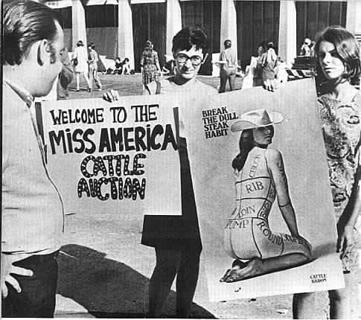 | 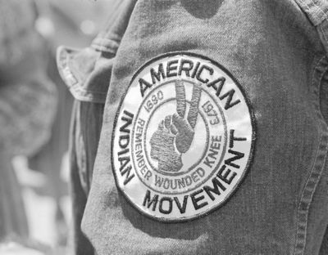
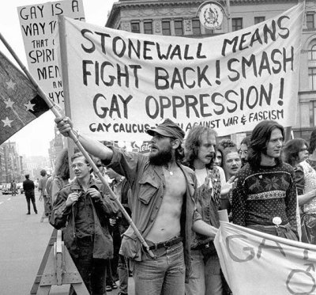  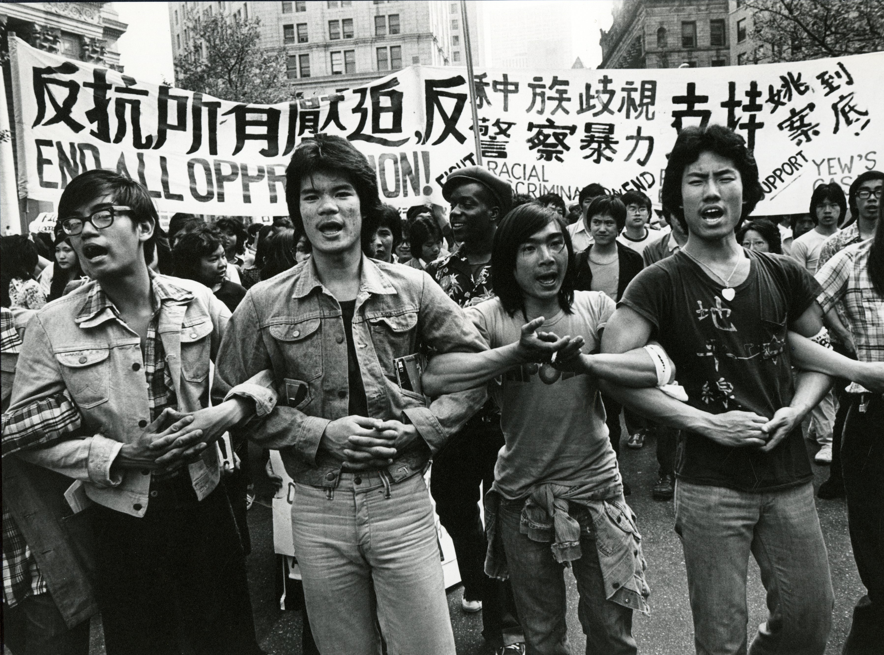 | 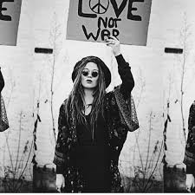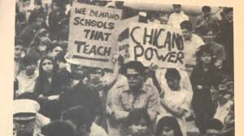

#2) Excerpt from Betty Friedan's The Feminine Mystique
"It is more than a strange paradox that as all professions are finally open to women in America, "career woman" has become a dirty word; that as higher education becomes available to any woman with the capacity for it, education for women has become so suspect that more and more drop out of high school and college to marry and have babies; that as so many roles in modern society become theirs for the taking, women so insistently confine themselves to one role. Why, with the removal of all the legal, political, economic and educational barriers that once kept woman from being man's equal, a person in her own right, an individual free to develop her own potential, should she accept this new image which insists she is not a person but a "woman," by definition barred from the freedom of human existence and a voice in human destiny?"

#3) Vietnam Era Political Cartoon
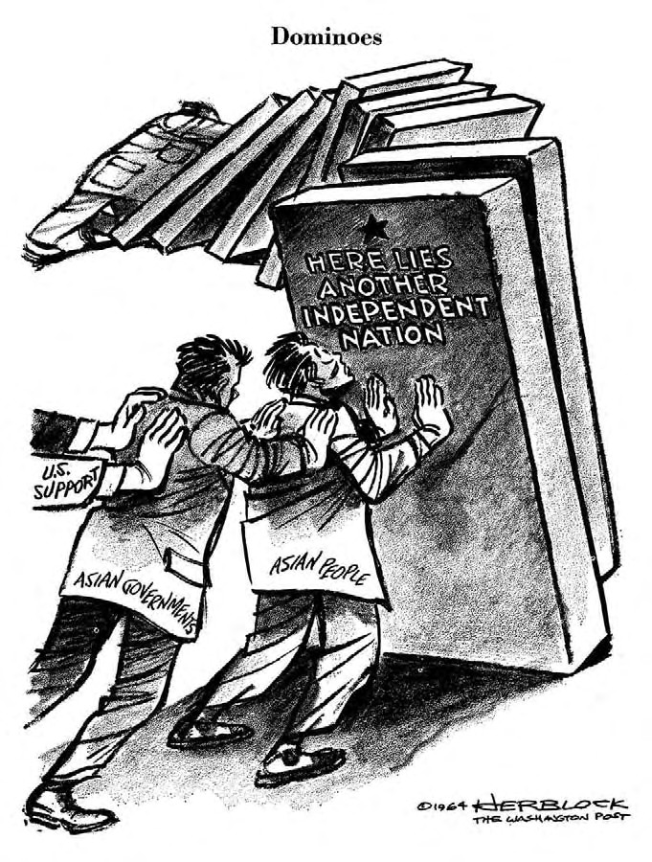

#4) Martin Luther King, Jr. Speech called "Beyond Vietnam"
"Perhaps a more tragic recognition of reality took place when it became clear to me that the war was doing far more than devastating the hopes of the poor at home. It was sending their sons and their brothers and their husbands to fight and to die in extraordinarily high proportions relative to the rest of the population. We were taking the black young men who had been crippled by our society and sending them eight thousand miles away to guarantee liberties in Southeast Asia which they had not found in southwest Georgia and East Harlem. And so we have been repeatedly faced with the cruel irony of watching Negro and white boys on TV screens as they kill and die together for a nation that has been unable to seat them together in the same schools. And so we watch them in brutal solidarity burning the huts of a poor village, but we realize that they would hardly live on the same block in Chicago. I could not be silent in the face of such cruel manipulation of the poor."

