Redemption Song by Bob Marley
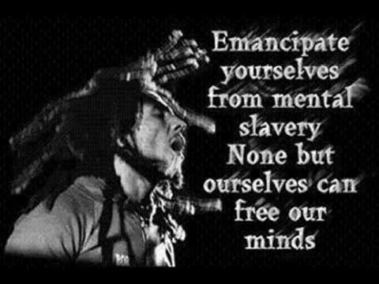

Old pirates, yes, they rob I,
Sold I to the merchant ships,
Minutes after they took I
From the bottomless pit.
But my head was made strong
By the hand of the Almighty.
We forward in this generation
Triumphantly.
Won't you help to sing
These songs of freedom?
'Cause all I ever have,
Redemption songs,
Redemption songs.
Emancipate yourself from mental slavery,
None but ourselves can free our minds.
Have no fear for atomic energy,
'Cause none of them can stop the time.
How long shall they kill our prophets,
While we stand aside and look?
Some say it's just a part of it,
We've got to fulfill the book.
Won't you help to sing
These songs of freedom?
'Cause all I ever have,
Redemption songs,
Redemption songs,
Redemption songs.
Emancipate yourself from mental slavery,
None but ourselves can free our mind.
Have no fear for atomic energy,
'Cause none of them can stop the time.
How long shall they kill our prophets,
While we stand aside and look?
Some say it's just a part of it,
We've got to fulfill the book.
Won't you help to sing,
These songs of freedom?
'Cause all I ever had,
Redemption songs.
All I ever had,
Redemption songs
These songs of freedom
Songs of freedom

