Modern Day Voter Restrictions
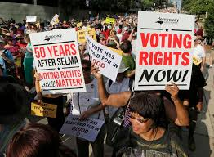
- We have seen how states in the Southern USA made it an important strategy from 1900-1965 to RESTRICT African-Americans and other minorities from voting. WHY?

- We saw that the 1964 Freedom Summer and 1965 Selma Campaign struggled to overcome these obstacles and achieved the success of the 1965 Voting Rights Act. Why was the 1965 Voting Rights Act such a big victory?

- Do you think there are still some people in the USA who 'secretly' or not even 'secretly' believe it is still a good strategy to limit African-Americans and other minorities from voting? Why?

- How might these people go about restricting minorities abilities to vote in modern times?

- In turns out that in 2013 the USA Supreme Court ruled that the 1965 Voting Rights Act is no longer necessary because 'racism has been overcome in the USA'; as a result, the federal government and Supreme Court no longer needs to worry about states trying to restrict minorities access to voting. What are your thoughts about this?

- What do you think some states have started doing since 2013? How? Why?

- Let's look at some articles about this….

- Click on this article: https://www.aclu.org/facts-about-voter-suppression

- Click on this article: https://www.brennancenter.org/our-work/analysis-opinion/worst-voter-suppression-weve-seen-modern-era

- Click on this article: https://www.theguardian.com/us-news/2019/nov/13/voter-suppression-2020-democracy-america

- What are your thoughts and questions about this?

- For Test Extra Credit- do more of your own research about this so very important topic. Tell me what you read or watched and take some notes on it and your thought on it. Email it to me.

