Possible Primary Documents on Unit 3 Test
On the Unit 3 Test you will have an option of 2 essay questions and you pick 1 to answer.
Each Essay Option will have 2 primary documents related to it. So on your test you will only see 4 of these documents. But I can use any of them.

Possible Source #1: Frederick Douglass Speech "What to the Slave is the Fourth of July"
What, to the American slave, is your Fourth of July?
I answer: a day that reveals to him, more than all other days in the year, the gross injustice and cruelty to which he is the constant victim. To him, your celebration is a sham; your boasted liberty, an unholy license; your national greatness, swelling vanity; your sounds of rejoicing are empty and heartless; your denunciation of tyrants, brass-fronted impudence; your shouts of liberty and equality, hollow mockery; your prayers and hymns, your sermons and thanksgivings, with all your religious parade and solemnity, are, to Him, mere bombast, fraud, deception, impiety, and hypocrisy-a thin veil to cover up crimes which would disgrace a nation of savages.
There is not a nation of savages. There is not a nation on the earth guilty of practices more shocking and bloody than are the people of the United States at this very hour.

Possible Source #2: Nat Turner's Jailhouse Confession
As I was praying one day at my plough, the spirit spoke to me, saying, “Seek ye the kingdom of Heaven and all things shall be added unto you.” Question—what do you mean by the Spirit. Answer- The Spirit that spoke to the prophets in former days—and I was greatly astonished, and for two years prayed continually, whenever my duty would permit—and then again I had the same revelation, which fully confirmed me in the impression that I was ordained for some great purpose in the hands of the Almighty. Several years rolled round, in which many events occurred to strengthen me in this my belief. At this time I reverted in my mind to the remarks made of me in my childhood, and the things that had been shewn me—and as it had been said of me in my childhood by those by whom I had been taught to pray, both white and black, and in whom I had the greatest confidence, that I had too much sense to be raised, and if I was, I would never be of any use to any one as a slave. Now finding I had arrived to man’s estate, and was a slave, and these revelations being made known to me, I began to direct my attention to this great object, to fulfil the purpose for which, by this time, I felt assured I was intended.

Possible Source #3 Lyrics to the Song "Follow the Drinking Gourd"
When the Sun comes back
And the first quail calls
Follow the drinking gourd,
For the old man is a-waiting for to carry you to freedom
If you follow the drinking gourd

The riverbank makes a very good road.
The dead trees will show you the way.
Left foot, peg foot, traveling on,
Follow the drinking gourd.

The river ends between two hills
Follow the drinking gourd.
There’s another river on the other side
Follow the drinking gourd.

Possible Source #4 John Brown's Last Words
I have, may it please the Court, a few words to say. In the first place, I deny everything but what I have all along admitted, the design on my part to free the slaves. I intended certainly to have made a clean thing of that matter, as I did last winter, when I went into Missouri and there took slaves without the snapping of a gun on either side, moved them through the country, and finally left them in Canada. I designed to have done the same thing again, on a larger scale…This court acknowledges, as I suppose, the validity of the law of God. I see a book kissed here which I suppose to be the Bible. That teaches me that all things whatsoever I would that men should do to me, I should do even so to them. It teaches me, further, to "remember them that are in bonds, as bound with them." I endeavored to act up to that instruction. I say, I am yet too young to understand that God is any respecter of persons. I believe that to have interfered as I have done as I have always freely admitted I have done in behalf of His despised poor, was not wrong, but right. Now, if it is deemed necessary that I should forfeit my life for the furtherance of the ends of justice, and mingle my blood further with the blood of my children and with the blood of millions in this slave country whose rights are disregarded by wicked, cruel, and unjust enactments, I submit; so let it be done!

Possible Source #5: Newspaper Political Cartoon about The Fugitive Slave Act

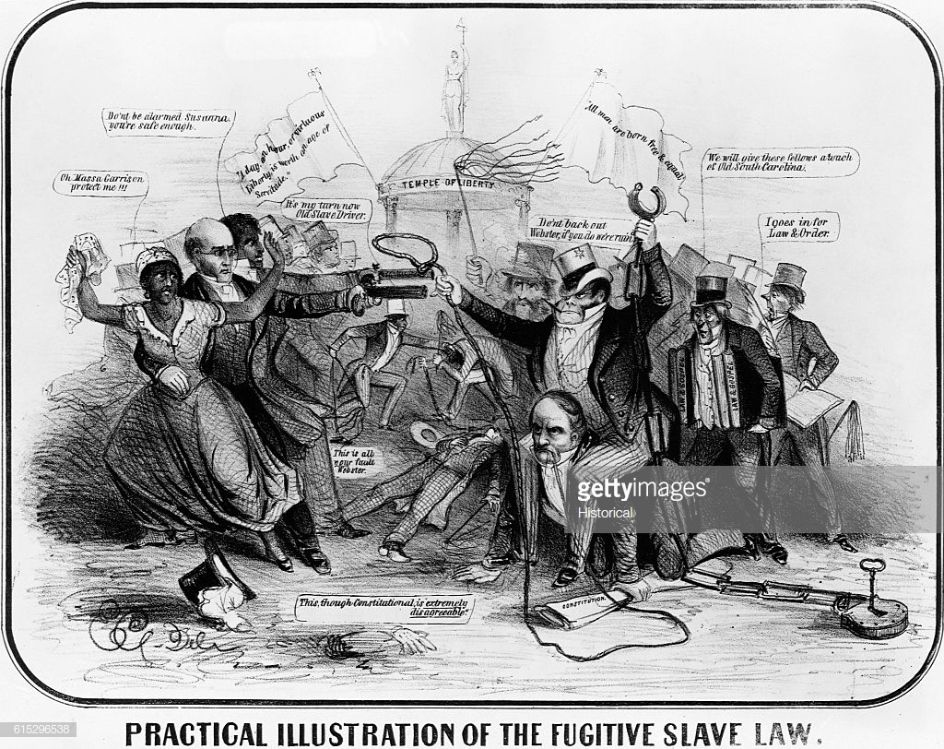

Possible Source #6: Political Cartoon about the Presidential Election of Abraham Lincoln:
