2022 Chinese New Year Extra Credit Opportunities
In case you get bored over Chinese New Year Break, you can do some of this special extra credit work to add points to your Unit Tests.
You do not have to do this over the break unless you want to. You have until May 20th to turn in Extra Credit Work for the 2nd Semester. But if you get bored over the break and want to do some extra credit then go for it!
Overview
- Do as many of these options as you want and EMAIL Your work to Mr. C directly
- You may only earn a maximum of +5 Points on any one Unit Test
- If you do more than +5 points on the Unit 5 Test- you can add the other points to your Unit 6 and Unit 8 Tests
Here are the Opportunities you may choose from:

- Watch one of these special movies related to Unit 5 Topics
-If you watch any of these following movies I will give you +4 points.
-So you can watch 2 movies for +8 points; watch 3 movies for +12 points, etc.

-In order to get the points…
a)It must be a movie from the following list and that you have never seen before
b)You must watch the entire movie
c) Here is what you need to write and submit for the points….

-Pause the movie after 30 minutes watching and write 2 things that happened in the first 30 minutes
-Then pause the movie again after 1 hour watching and write 2 more things that happened in the movie in-between 30 minutes and 1 hour
-Then watch the rest of the movie and write 2 more things that happened in the final hour (or more) of the movie
-Finally- after you watch the entire movie write about 1 page Reflection on how the movie relates to US History class and US History themes and what you thought about the movie.

-Email Mr. Ciambarella your answers to get +4 points for each movie you watch
-Here are the possible movies:

- It's a Wonderful Life 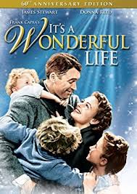 (1946- version!)
Maybe the greatest movie of all time. It's about Christmas- but it's also about how the USA changes with Industrial capitalism and during WWI and The Great Depression.

- To Kill a Mockingbird (1962 version!)
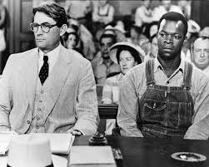
Maybe the second greatest movie ever made and maybe the greatest USA novel ever. It talks about the struggles of African-Americans after the Civil War era.

- Sounder (1972 movie version!)
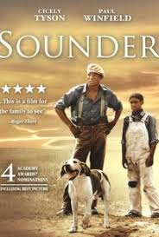

I swear reading this book as a boy changed my life. It's my all time favorite book. And I loved the movie too. Make sure you watch the 1972 movie version. It is the best movie about African-American families struggling during Reconstruction era in the South.

- The Color Purple (1982)
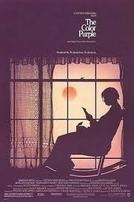
Steven Spielberg masterpiece movie based on Alice Walker's masterpiece novel about African-American women, strength, and resistance in the late 1800s USA!

- A League of Their Own (1992)
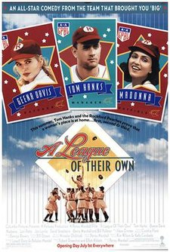
A comedy and fun movie, but also a true US History story of the creation of an all-girls Professional Baseball League during the War.

- Netflix Remastered: Devil at the Crossroad- A Robert Johnson Story
A Netflix movie about the “original founder” of BLUES MUSIC in the USA- Robert Johnson- and how his music and influence later becomes rock n roll, hip-hop, and rap….
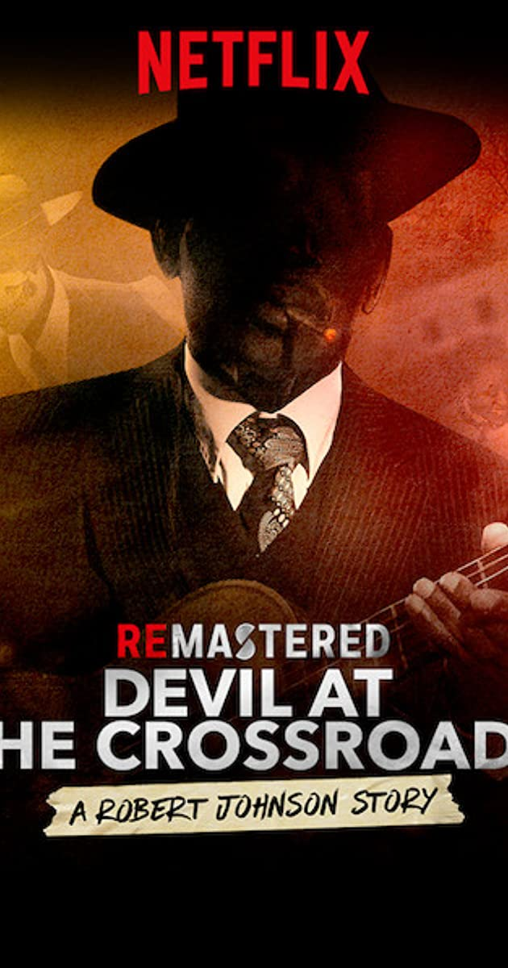

- Netflix new movie: Ma Rainey’s Black Bottom
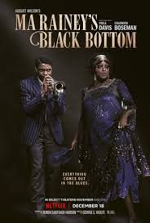
New Netflix movie about the leading women’s blues singer of the 1920s and 30s- Ma Rainey

- Seabiscuit (2003)
A true story about a small horse that becomes a horse racing champion during the Great Depression
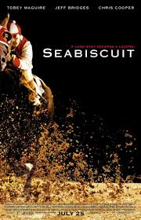

- The Grapes of Wrath (1940)
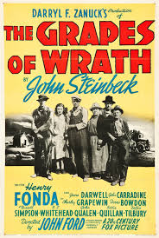
The movie version of the book. One of the greatest novels and stories of US History by John Steinbeck. It is about a poor farming family during The Great Depression

- 2. Do individual and independent research on a CURRENT EVENT that you think is related to US History class. You can choose any of the options below without asking MR. C.
Or if you want to do your own topic then YOU MUST GET MR. C's APPROVAL OF A DIFFERENT TOPIC BEFORE YOU START TO RESEARCH IT. So just ask or email Mr. C first if your topic is OK. Once Mr. C approves your topic then you are rewarded on how much extra research you do, but here are the general rules:
- You cannot get more than +3 points for any one topic.
- Essentially you get +1 point for each page of research notes that you take.
- You always must tell me clearly what source you are using.
- The notes can be bullet points or sentences
- You cannot just commit plagiarism; the notes should be your original notes
- You can decide which Unit Test these extra points go towards.

