Pro- Indian Removal Act Primary Documents

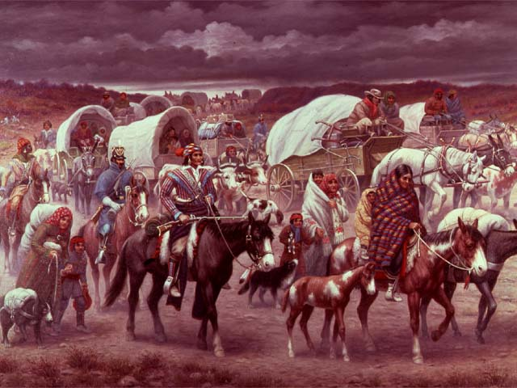
The Trail of Tears, was painted by Robert Lindneux in 1942.

Indian Removal
Document A: Andrew Jackson (Modified)
It gives me great pleasure to announce to Congress that the
Government’s benevolent policy of Indian removal has almost been
achieved.
We have wept over the fate of the natives of this country, as one by
one many tribes have disappeared from the earth. However, we
must accept this the way we accept when an older generation dies
and makes room for the younger.
We would not want to see this continent restored to the condition in
which our forefathers found it. What good man would prefer a
country covered with forests and occupied by a few thousand
savages to our great Republic, studded with cities, towns, and
prosperous farms, decorated with art and industry, occupied by
more than 12,000,000 happy people, and filled with all the
blessings of liberty, civilization, and religion?
The United States will pay to send the natives to a land where they
may live longer and possibly survive as a people.
Can it be cruel when this Government offers to purchase the
Indian’s land, give him new and extensive territory, pay the
expense of his removal, and support him for the first year in his
new home? How many thousands of our own people would gladly
embrace the opportunity of moving West under such conditions!
The policy of the Government towards the red man is generous.
The Indian is unwilling to follow the laws of the States and mingle
with the population. To save him from utter annihilation, the
Government kindly offers him a new home, and proposes to pay
the whole expense of his removal and settlement.
Source: Andrew Jackson, State of the Union speech. December 30, 1830.

Indian Removal
Document B: Letter by Elias Boudinot (Modified)
Look at our people! They are wretched! Look, my dear sir, around
you, and see the progress that vice and immorality have already
made! See the misery!
If the darker picture which I have described here is a true one, can
we see a brighter possibility ahead? In another country, and under
other circumstances, there is a better prospect. Removal, then, is
the only remedy, the only practical remedy. Our people may finally
rise from their very ashes, to become prosperous and happy, and a
credit to our race. I would say to my countrymen, fly from your life
here that is destroying our nation.
What is your (John Ross) plan of relief? It is dark and gloomy
beyond description. You want the Cherokee to live according the
laws of Georgia, no matter how unfair they are? Instead of fix the
evil, you would tie our people down in the chains of slavery. The
final destiny of our race, under such circumstances is too revolting
to think of. Take my word, it is the sure end of our race if you
succeed in preventing the removal of your people. There will come
a time when there will be few of us left as reminders of this brave
and noble race. May God protect us from such a destiny.
Source: The letter above was written in 1837 by Elias Boudinot, a Cherokee
who supported Indian Removal (and who signed the Treaty of New Echota
that gave away Cherokee land). The letter is to Chief John Ross, leader of the
Cherokees who opposed Indian Removal.

